

Online Vehicle Rental and Hiring Management System

(Easy Rent)

Information Technology Project – ITP2080

**ITP_WD_B04_04**

Final Report

**Team Members:**

1. IT22580344 - Jayasekara M.P.S.S
2. IT22286246 - Chandrasekara C.M.P.V
3. IT22137128 - Wijewantha H.D.C
4. IT22230638 - Nathasha K.D.S
5. IT22101242 - Tharuka M.S
6. IT22124876 - Silva M.W.P.R.K
7. IT22271150 - Abeysekara.W.R.G.M
8. IT22281128 - Jayasundara J.M.T.P

Submitted to: ………………………

(Mr.HarshanathSMB)

Date of submission:

# Declaration

We declare that this project report or part of it was not a copy of a document done by any organization, university any other institute or a previous student project group at SLIIT and was not copied from the Internet or other sources.

Project Details

|  |  |
| --- | --- |
| Project Title | Online Vehicle Rental and Hiring Management System  (EasyRent) |
| Project ID | ITP_WD_B04_04 |

Group Members

|  |  |
| --- | --- |
| **Reg. No** | **Name** |
| IT22580344 | Jayasekara M.P.S.S |
| IT22286246 | Chandrasekara C.M.P.V |
| IT22137128 | Wijewantha H.D.C |
| IT22230638 | Nathasha K.D.S |
| IT22101242 | Tharuka M.S |
| IT22124876 | Silva M.W.P.R.K |
| IT22271150 | Abeysekara.W.R.G.M |
| IT22281128 | Jayasundara J.M.T.P |

# Abstract

Easy Rent is an advanced vehicle renting and hiring management system designed to streamline and enhance the operations of vehicle rental businesses. Our system provides a comprehensive platform for managing the end-to-end rental process, from vehicle inventory management to customer reservations and payments.

The core features of Easy Rent include a user-friendly interface for both customers and administrators, a robust vehicle management module, secure online payment processing, and detailed reporting and analytics. Customers can effortlessly browse available vehicles, make reservations, and manage their bookings through an intuitive online portal.

For administrators, Easy Rent offers powerful tools for managing vehicle fleets, tracking maintenance schedules, and monitoring rental activities. The system supports various types of vehicles, including cars, motorcycles, trucks, and specialty vehicles, ensuring versatility for different business needs.

Easy Rent leverages modern technologies to provide a seamless and secure experience. The system is built with scalability in mind, allowing it to grow with the business and adapt to changing market demands. Our focus on user experience, efficiency, and security ensures that both customers and administrators benefit from a reliable and hassle-free solution.

In conclusion, Easy Rent aims to revolutionize the vehicle rental industry by providing a comprehensive, efficient, and user-friendly management system. By automating and optimizing key processes, Easy Rent helps rental businesses improve their operations, enhance customer satisfaction, and drive growth.

# Acknowledgement

We would like to extend our heartfelt gratitude to everyone who has contributed to the development of Easy Rent, our vehicle renting and hiring management system. This project would not have been possible without the unwavering support and guidance of our colleagues.

Firstly, we thank our development team for their dedication, hard work, and innovative approach to solving complex problems. Your expertise and collaboration were crucial in bringing Easy Rent to life.

We are deeply grateful to our lecturer Mr.HarshanathSMB for their invaluable insights, feedback, and encouragement throughout this project. Your experience and wisdom helped shape Easy Rent into a robust and user-friendly system.

Lastly, we appreciate the trust and cooperation of our stakeholders and partners. Your belief in our vision and your constructive collaboration were vital to the success of this project.

Thank you all for being part of this journey. Together, we have created a system that aims to revolutionize the vehicle renting and hiring industry.

# Table of Contents

Declaration 2

Abstract 3

Acknowledgement 4

Table of Contents 5

1. Introduction 7

1.1 Client/Company Background 7

1.2 Problem Statement 7

1.2.1 Challenges for Vehicle Owners: 7

1.2.2 Challenges for Renters: 7

1.2.3 Challenges for Drivers: ………………………………………………………………………………………9

1.3 Motivations 8

1.3.1 Motivations for Vehicle Owners: 8

1.3.2 Motivations for Renters: 8

1.3.3 Motivations for Drivers: …………………………………………………………………………………

1.4 Aim 9

1.5 Objectives 9

1.5.1 For Vehicle Owners: 9

1.5.2 For Renters: 10

1.5.3 For Drivers: ……………………………………………………………………………………………………….

1.6 The functions handled by the system are 11

1.6.1 Customer Management System 11

1.6.2 Owner Management System 11

1.6.3 Driver Management System 11

1.6.4 Vehicle Management System 11

1.6.5 Booking & Payment Management System 11

1.6.6 Maintenance Management System 12

1.6.7 Review and Rating Management System 12

1.6.8 HR Management System 12

1.7 Project Report Structure 13

Chapter 1 – Requirement Analysis 13

Chapter 2 – Design 13

Chapter 3 – Implementation 13

Chapter 4 – Testing 13

Chapter 5 – Conclusion 13

2. Methodology 14

2.1 Requirement Analysis 14

2.1.1 Use Case Diagrams 14

2.1.2 Activity Diagrams 21

2.2 Design 31

2.2.1 High Level Architecture Diagram 31

2.2.2 ER Diagram 32

2.2.3 Class Diagram 33

2.2.4 Sequence Diagrams 34

2.2.5 Interfaces 40

2.3 Implementation 67

2.3.1 Tools and Technology 70

2.3.1.1 Project Management and Documentation: 70

2.3.1.2 Modeling and Drawing Tools: 70

2.3.1.3 Design and User Interface: 70

2.3.1.4 Programming Languages and Development Environments: 70

2.3.1.5 Application Development: 71

2.3.1.6 Full-Stack Development: 71

2.4 Testing 72

4. Conclusion 79

# Introduction

## 1.1 Client/Company Background

Our system caters to four main types of clients: Vehicle Owners, Renters, Drivers, and System Employees.

Vehicle Owners have the ability to list their vehicles on our platform, specifying their availability for rent or hire.

System Employees, particularly those in the Maintenance team, perform regular check-ups on these listed vehicles to ensure they are in optimal condition for use.

Renters have the flexibility to book a vehicle for either rent or hire, after checking its availability. For hires, the vehicle owner assigns a driver for the trip.

The system also facilitates seamless transactions. Renters can make payments directly through the system for their bookings. Similarly, Vehicle Owners can use the system to pay the Drivers for their services.

## 1.2 Problem Statement

### 1.2.1 Challenges for Vehicle Owners:

* Limited Exposure: Manual systems lack a dedicated platform to list vehicles, hindering their reach to potential renters and limiting their earning potential.
* Inefficient Booking Management: Managing bookings through phone calls or emails is time-consuming, prone to errors, and increases the risk of double bookings.
* Transparency Issues: Tracking earning history and payments from renters is difficult, leading to ambiguity and potential disputes.
* Manual Workload: Generating bills manually is tedious and error-prone, consuming unnecessary time and effort.

### 1.2.2 Challenges for Renters:

* Limited Search Options: Filtering and selecting vehicles based on preferences and real-time availability is difficult without a proper platform, leading to inefficient searches.
* Inefficient Communication: Constant calls or meetings with vehicle owners to check availability are inconvenient and time-consuming.
* Lack of Visibility: Inability to view booking history and future bookings hinders planning and managing rental schedules.
* Limited Payment Options: Paying in cash or through manual methods can be inconvenient and lack security compared to online options.
* Absence of Reviews and Ratings: Difficulty in assessing the reliability of vehicles and owners due to lack of readily available feedback mechanisms.

### 1.2.3 Challenges for Drivers:

* Time Management: Drivers need to manage their time effectively to meet rental schedules, pick up and drop off passengers on time.
* Safety and Security: Ensuring the safety and security of passengers and rented vehicles is a critical challenge for drivers.
* Regulatory Compliance: Adhering to local laws, regulations, and licensing requirements related to driving, vehicle operations, and rental services poses a challenge for drivers.
* Navigating Unfamiliar Routes: Drivers often face challenges when navigating unfamiliar routes, areas with complex road networks or heavy traffic.

## 1.3 Motivations

### 1.3.1 Motivations for Vehicle Owners:

* Increase earnings: By reaching a wider audience through an online platform, owners can attract more renters and potentially increase their income.
* Save time and effort: A streamlined booking system eliminates the need for manual communication and reduces the risk of errors, freeing up valuable time and resources. Gain transparency: Automatic tracking of earnings and payments provides clear financial records and reduces the potential for disputes.
* Reduce workload: Automated billing eliminates the need for manual work, saving time and minimizing the risk of errors.

### 1.3.2 Motivations for Renters:

* Find vehicles easily: Advanced search filters allow for efficient searching based on specific criteria, saving time and effort.
* Convenient booking: Online booking eliminates the need for repeated calls or meetings, offering a more convenient and time-saving experience.
* Better planning: Access to booking history and future bookings allows for improved planning and organization of rental schedules.
* Secure payment options: Online payment methods offer convenience and security compared to traditional methods.
* Informed decision-making: Access to customer reviews and ratings helps renters make informed choices about vehicles and owners.

### Motivations for Drivers:

* Earning Potential: The potential to earn a decent income, especially during peak rental periods or through bonuses and incentives based on performance.
* Positive Feedback and Recognition: Appreciation from customers, positive reviews, and recognition for good performance can boost drivers' morale and motivation.
* Variety in Work: Driving different types of vehicles, meeting new people, and visiting various locations can provide variety and excitement in the job.
* Independence: Drivers in vehicle rental systems often enjoy a sense of independence and autonomy in their work.

## 1.4 Aim

To empower individual vehicle owners with limited resources by providing a comprehensive and user-friendly software platform for managing their rental businesses.

## 1.5 Objectives

### 1.5.1 For Vehicle Owners:

* Increase reach and visibility: Enhance exposure to potential renters by 70% through the online platform within the first year.
* Simplify rental management: Streamline booking, communication, and financial processes, reducing management time by 50% within six months.
* Gain financial control: Ensure 100% transparency in earnings and payments through automated tracking and reporting.

### 1.5.2 For Renters:

* Access diverse vehicle options: Expand search options to include vehicles from individual owners, increasing rental availability by 30% within the first year.
* Enjoy a seamless booking experience: Facilitate convenient online booking for all listed vehicles.
* Benefit from competitive pricing: Enable access to potentially lower rental rates offered by individual owners.
* Maintain secure transactions: Integrate secure online payment options for all rental transactions.

### 1.5.3 For Drivers:

* Safe and Reliable Transportation: The primary objective is to provide safe and reliable transportation services to customers.
* Timely Delivery and Pickup: Drivers should aim to meet rental schedules promptly.
* Excellent Customer Service: Providing excellent customer service by being helpful, and responsive to customer needs.
* Effective Communication: Communicating effectively with customers, support staff, and other stakeholders to coordinate pickups, drop-offs, and any issues.

# 1.6 The functions handled by the system are

## 1.6.1 Customer Management System

* The main user is Renter
* Renter can register into the system by using personal information
* Renters can manage their profiles and if they want they can delete the account permanently
* If a renter faced to a accident while the hiring or renting our vehicle those details are saving in our system database.
* Renters can filter vehicles according to their ideas.
* If renters found a vehicle they can add them into the Favorite list

## 1.6.2 Owner Management System

* The main user is vehicle owner.
* Can register and create profiles by providing personal details.
* Capability to add, update or delete vehicle information as needed and also can assign drivers to the relevant booking.
* Owners receive notifications for new booking requests and other updates including payments and can generate reports about the vehicle details.

## 1.6.3 Driver Management System

* The main user is the driver.
* Drivers interested in joining the platform can follow the registration process and the system verifies the driver's identity, driving license, and other required credentials. After a successful verification, a driver profile is created in the system.
* The system manages and stores essential documents such as driving licenses.
* Drivers can view the location, reserved date, no. of days through the system.
* Performance metrics, such as driving behavior, response to traffic rules, and customer feedback, are collected and analyzed. Complaints to the drivers will be notified to the relevant driver.

## 1.6.4 Vehicle Management System

* The main users are renters owners and drivers
* When vehicle approved from the maintenance test add that vehicle into the system
* Investigate all the complains on the specific vehicle when some one put a complain on that.
* If needed remove vehicles from the system database(if done any prohibited tasks)
* Put vehicles Into the maintenance at a specific time period

## 1.6.5 Booking & Payment Management System

* The main users are vehicle owner and renter.
* Tasks include adding, updating, delete and search booking requests for renter.
* Tasks include approving or rejecting booking requests and add additional cost and generating bill for vehicle owner.
* Using strip payment gateway renter can pay the bill online.
* Both owner and renter can generate reports showing the billing history and earnings.

## 1.6.6 Maintenance Management System

* The main user is the maintenance manager.
* Tasks include adding, updating, delete and search vehicle details for maintain vehicles.
* Using a form maintenance manager can update vehicle conditions and view them.
* The maintenance manager can view the oil level, tire condition, engine repair and no of date through the system.

## 1.6.7 Review and Rating Management System

## 1.6.8 HR Management System

* The main users are the HR manager, employee.
* Tasks include managing employee records such as adding, updating, and deleting employee information.
* Responsible for tracking employee attendance, calculating working hours and generating payroll.
* Tasks include managing employee leave requests and approvals.
* Generate reports on employee details.

# Project Report Structure

## Chapter 1 – Requirement Analysis

The system’s requirements and scope are articulated through diagrams. By examining these charts, one can comprehend the functions executed by each user and the sequence of steps undertaken in each section.

## Chapter 2 – Design

The system’s design details are illustrated. It provides a quick overview of how the system processes each function, using sequence diagrams and state chart diagrams. To help the reader understand the user interface, snapshots of the interfaces are included.

## Chapter 3 – Implementation

The discussion revolves around the selection of technology for the project and the rationale behind these choices. It also highlights the benefits that the chosen technologies bring to both the development team and the users.

## Chapter 4 – Testing

It incorporates test cases for the main functions to verify that the system operates as intended.

## Chapter 5 – Conclusion

States the conclusion reached by the development team at the end of the project. Discusses both positive and negative points in the developed system and the benefits of the system to the client.

# Methodology

## 2.1 Requirement Analysis

### 2.1.1 Use Case Diagrams

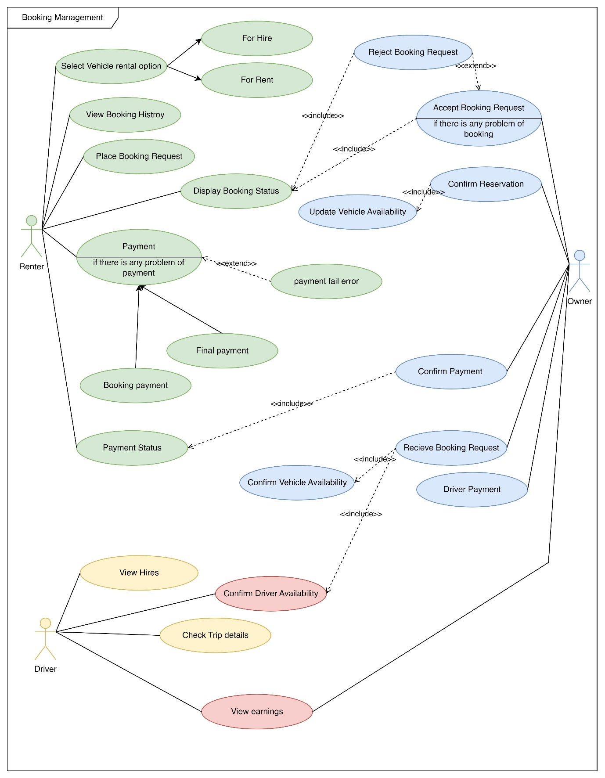

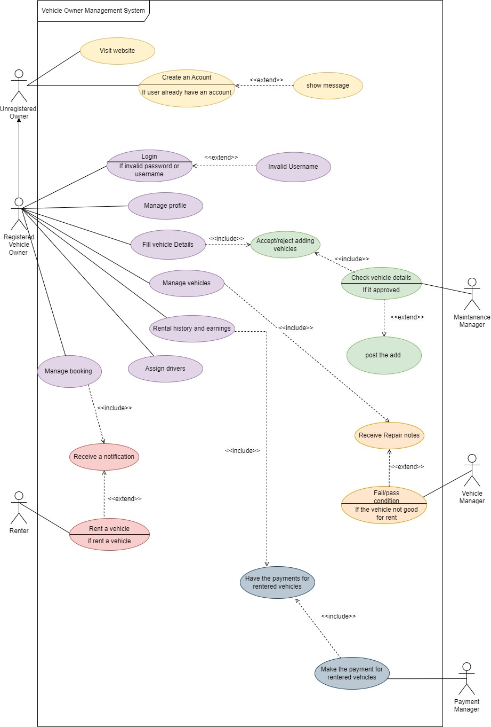

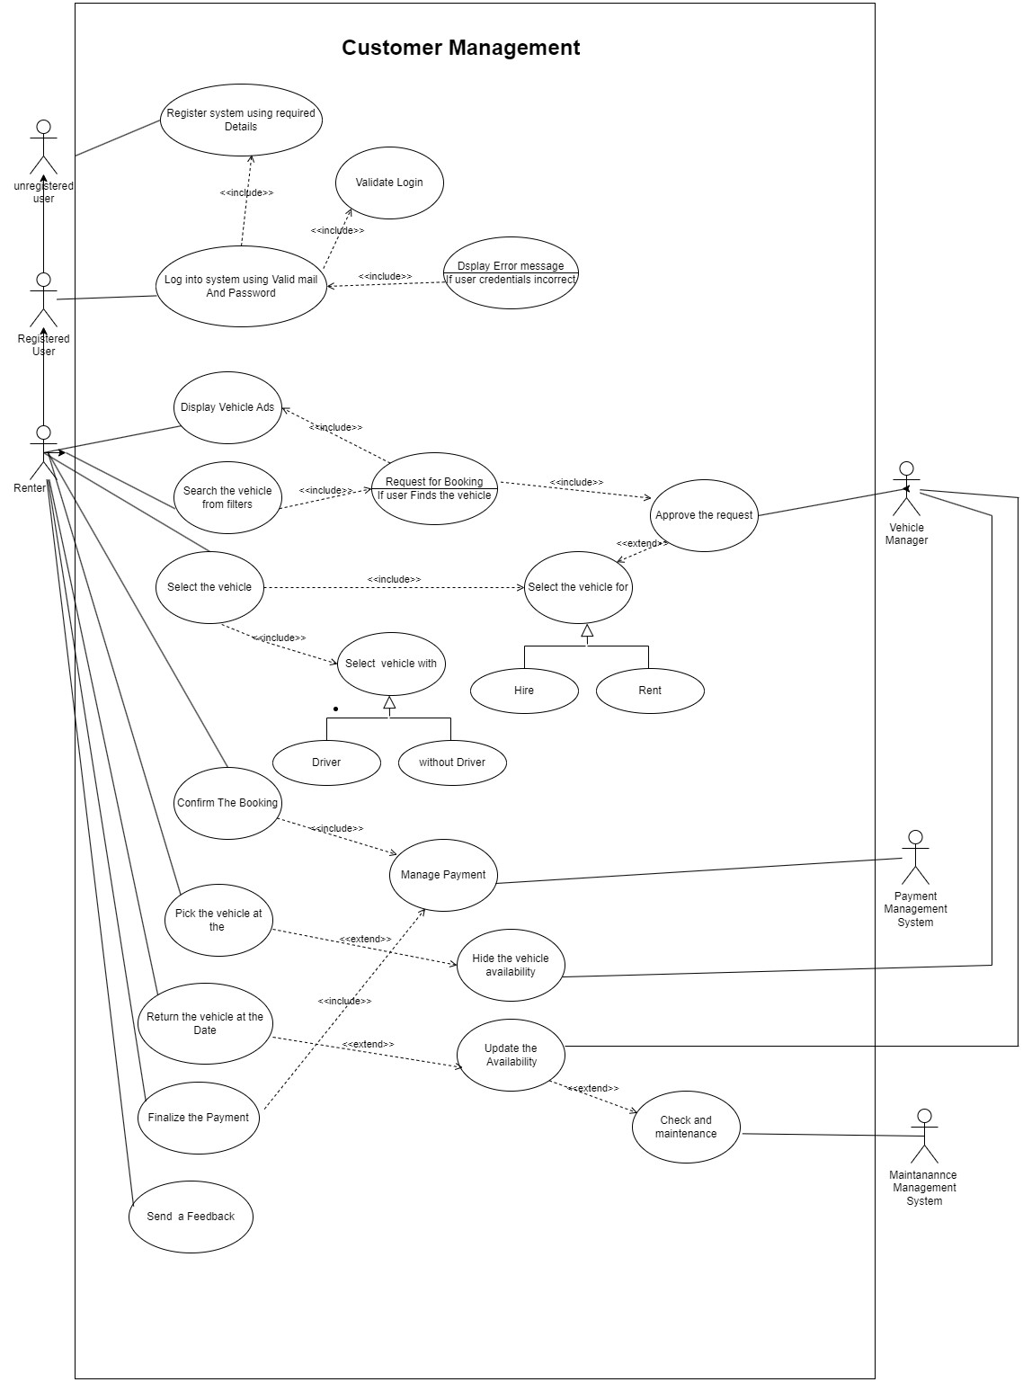

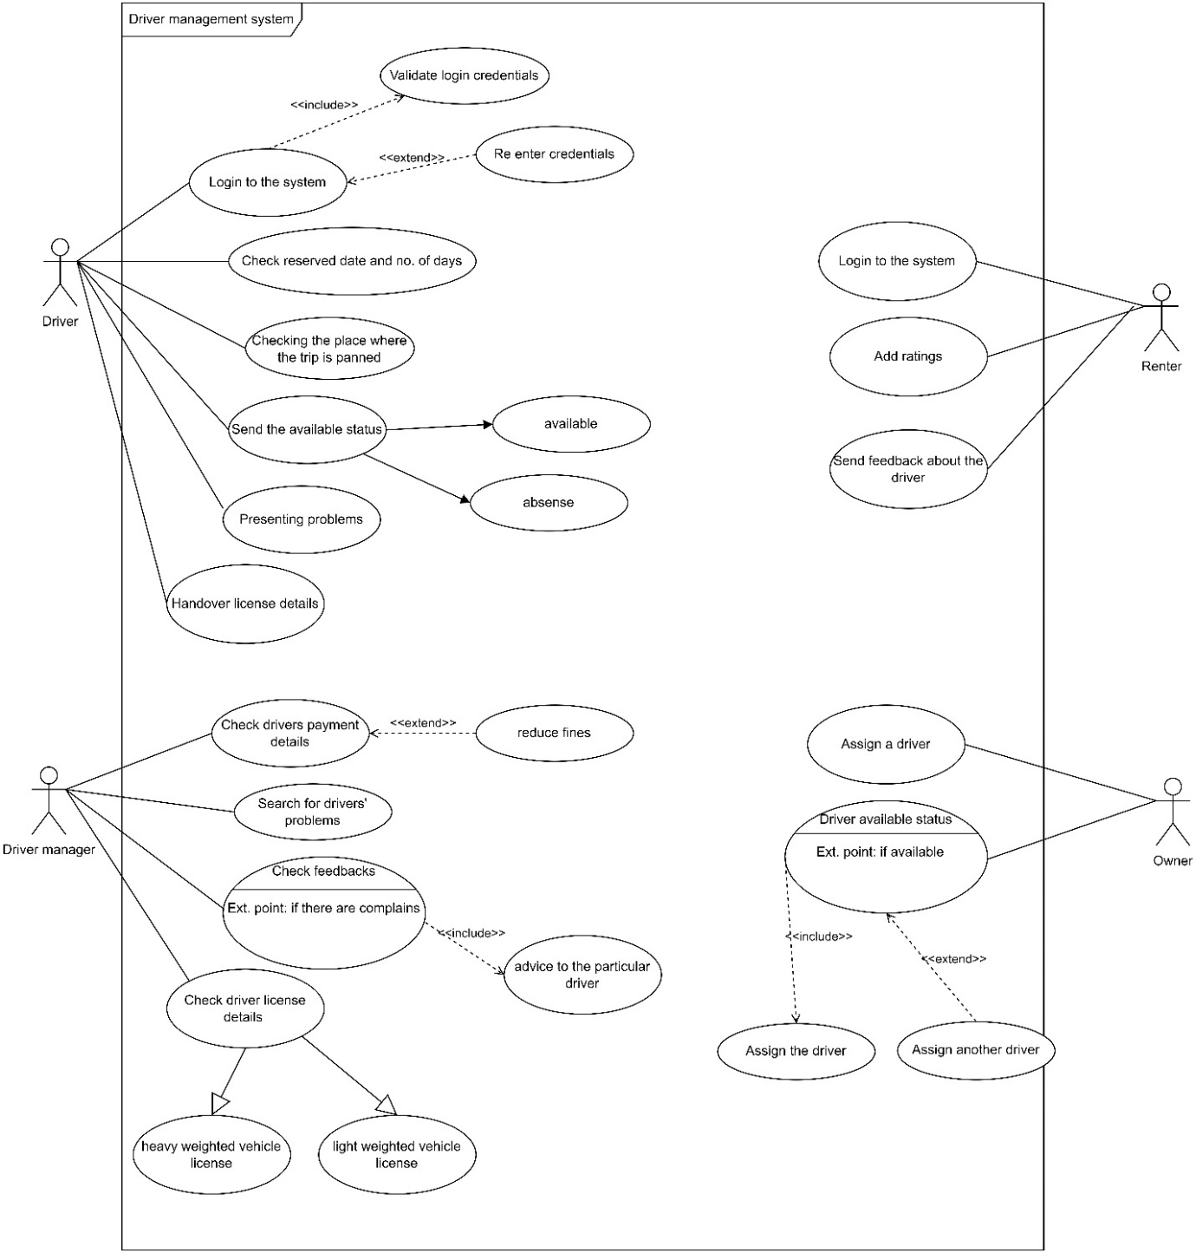

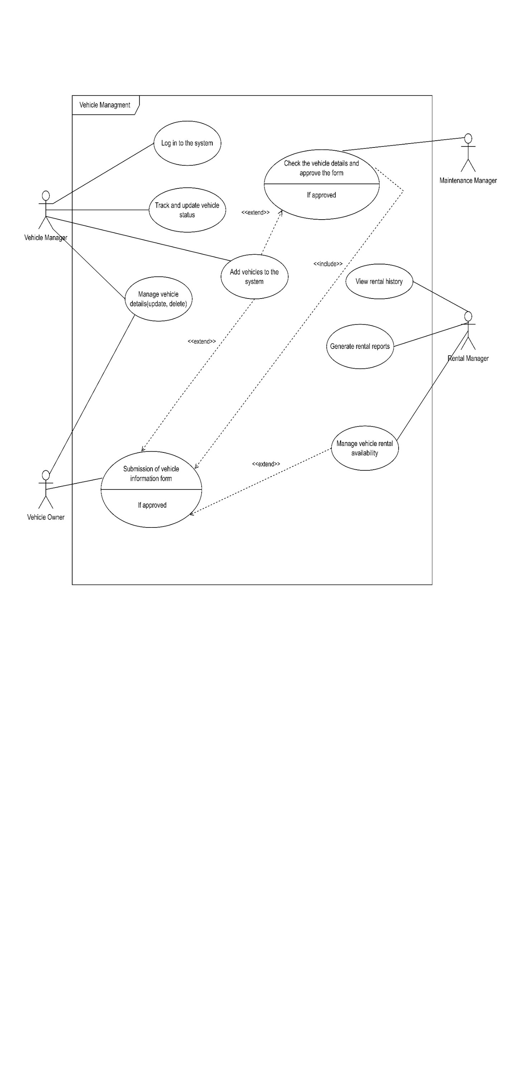

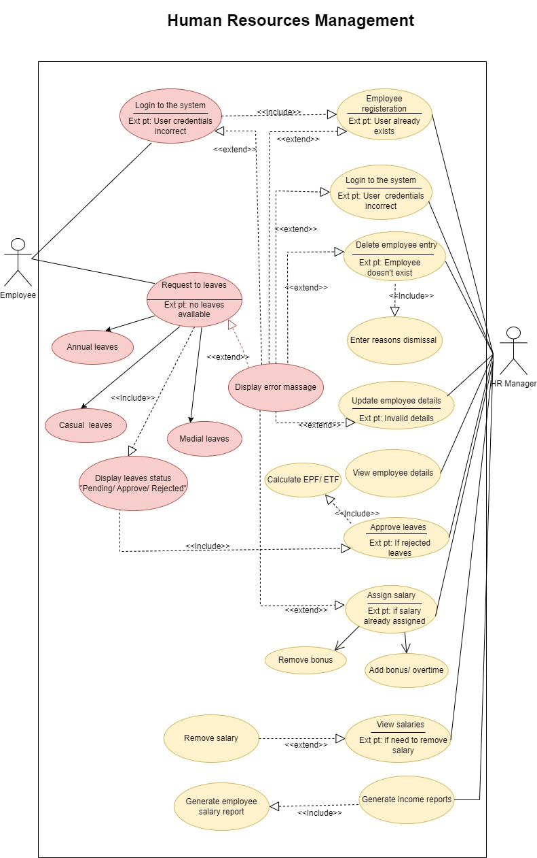

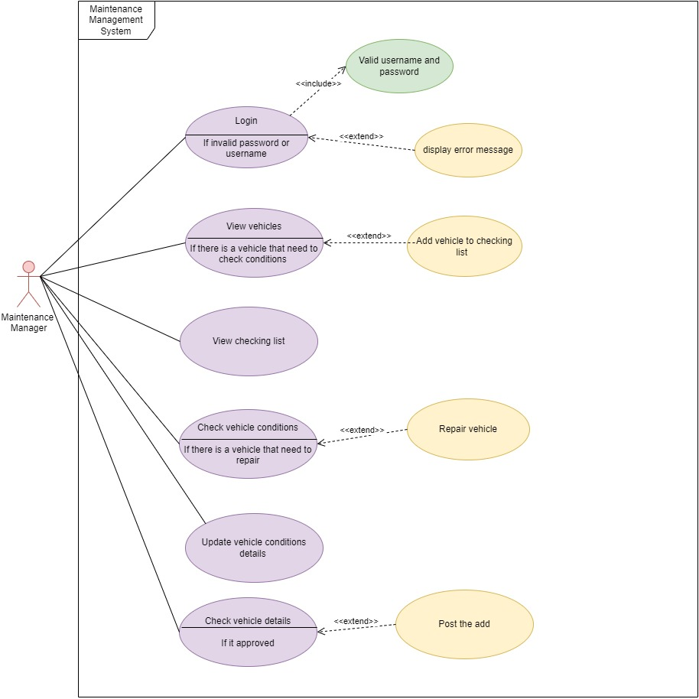

### 

### 2.1.2 Activity Diagrams

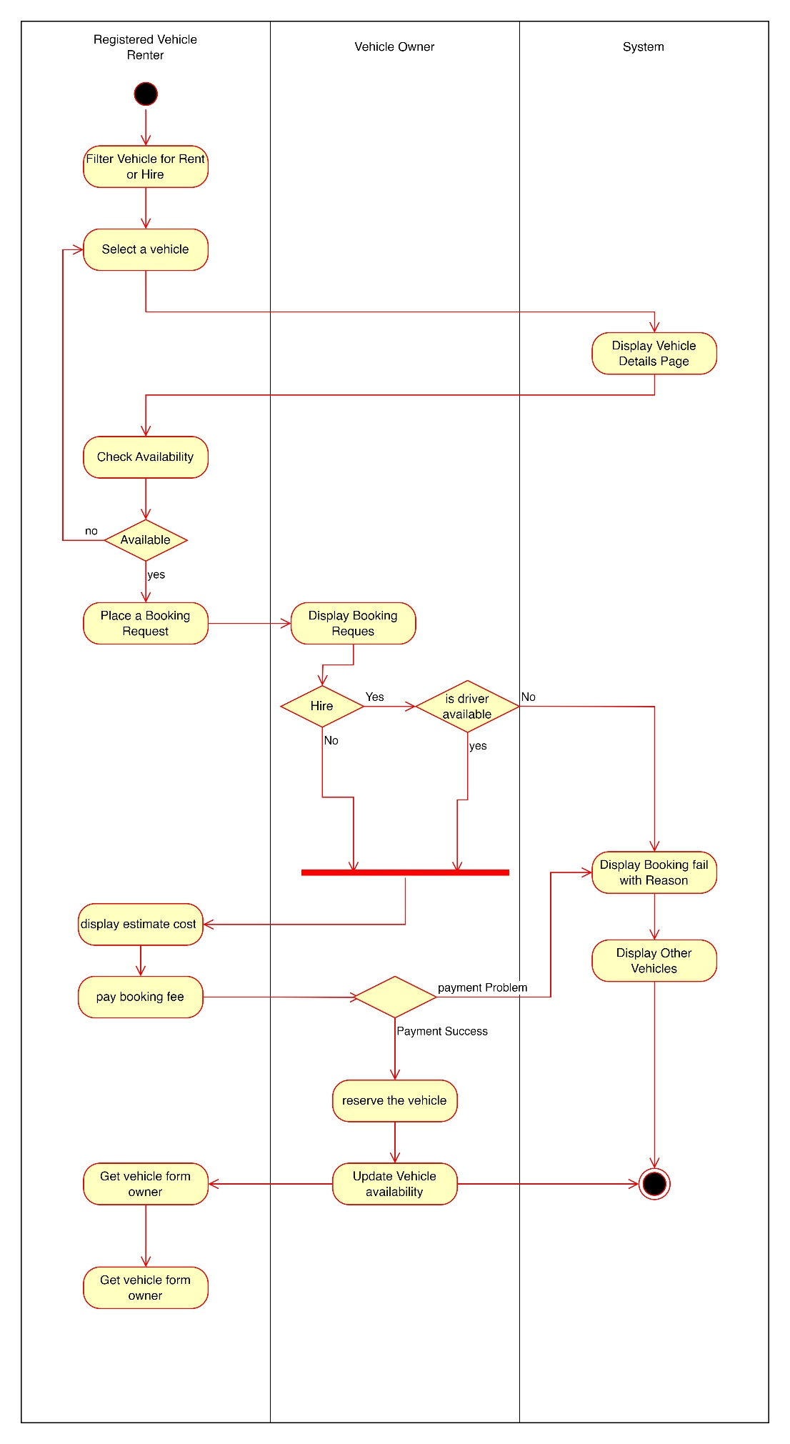

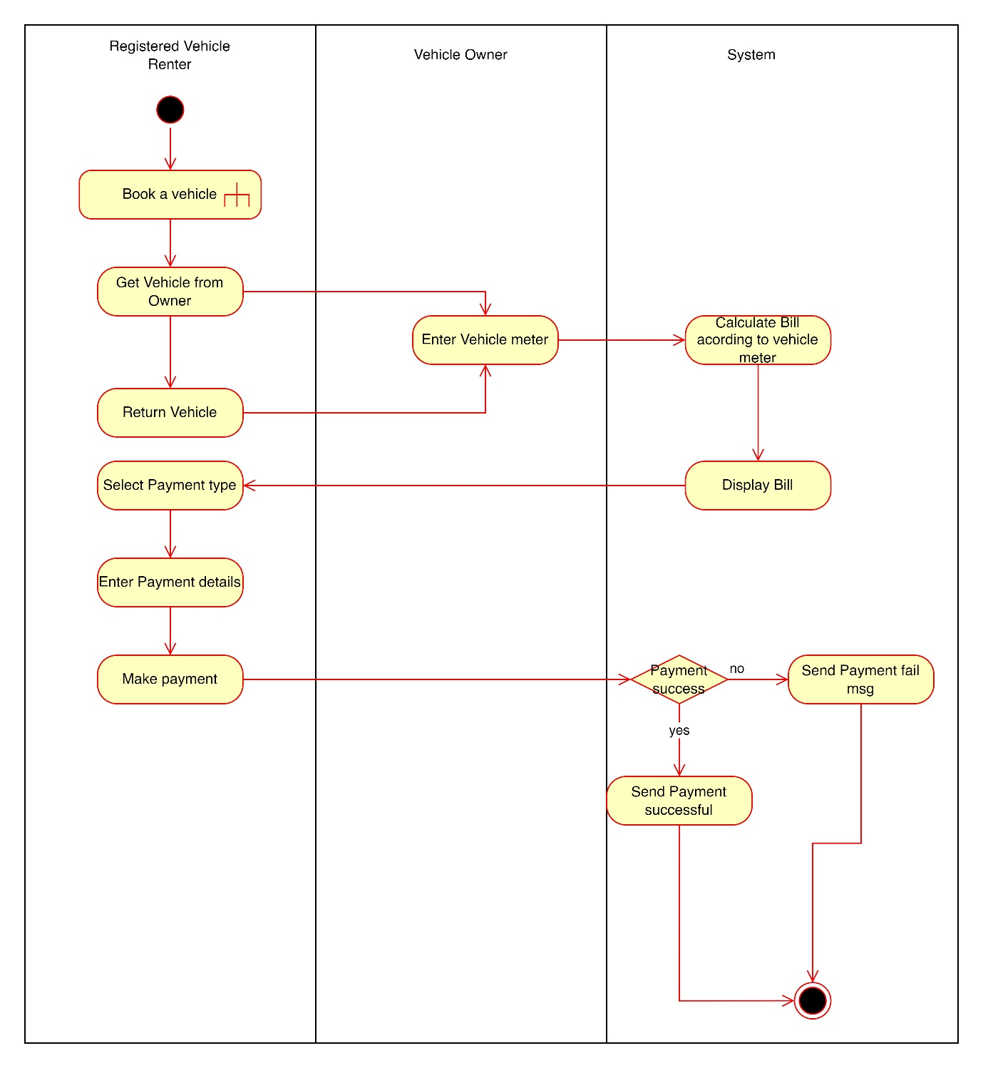

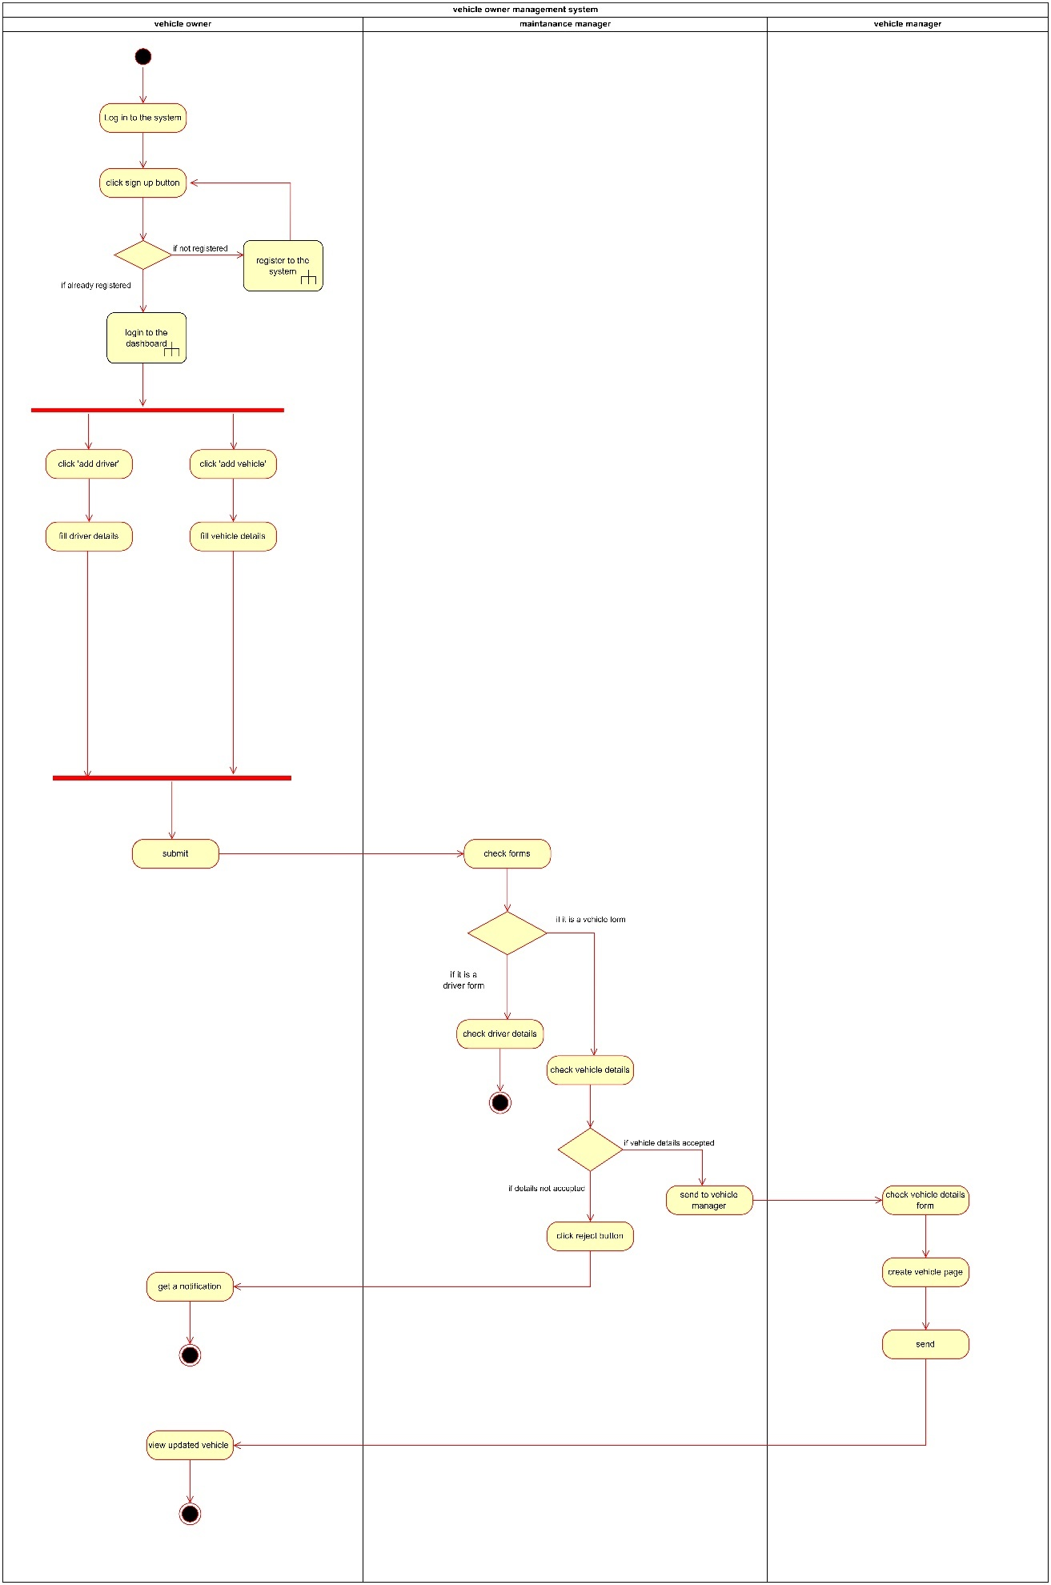

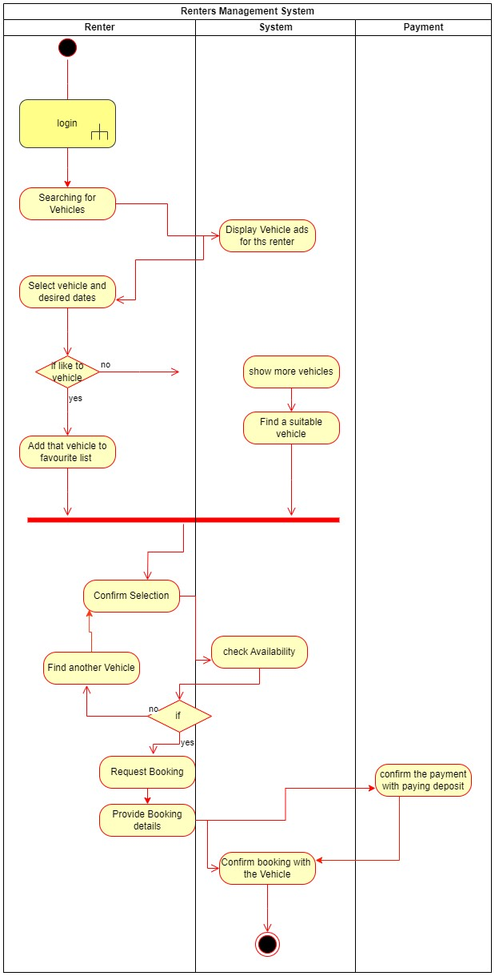

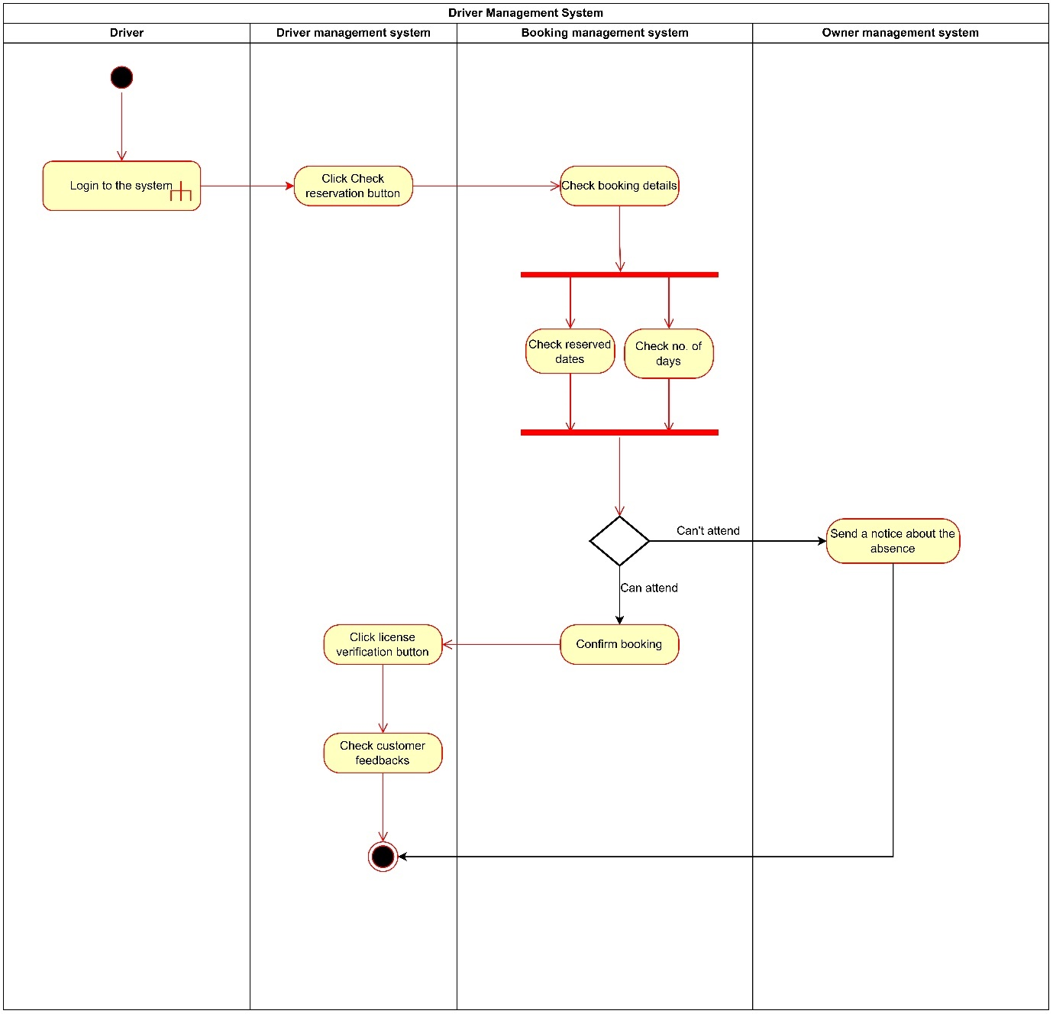

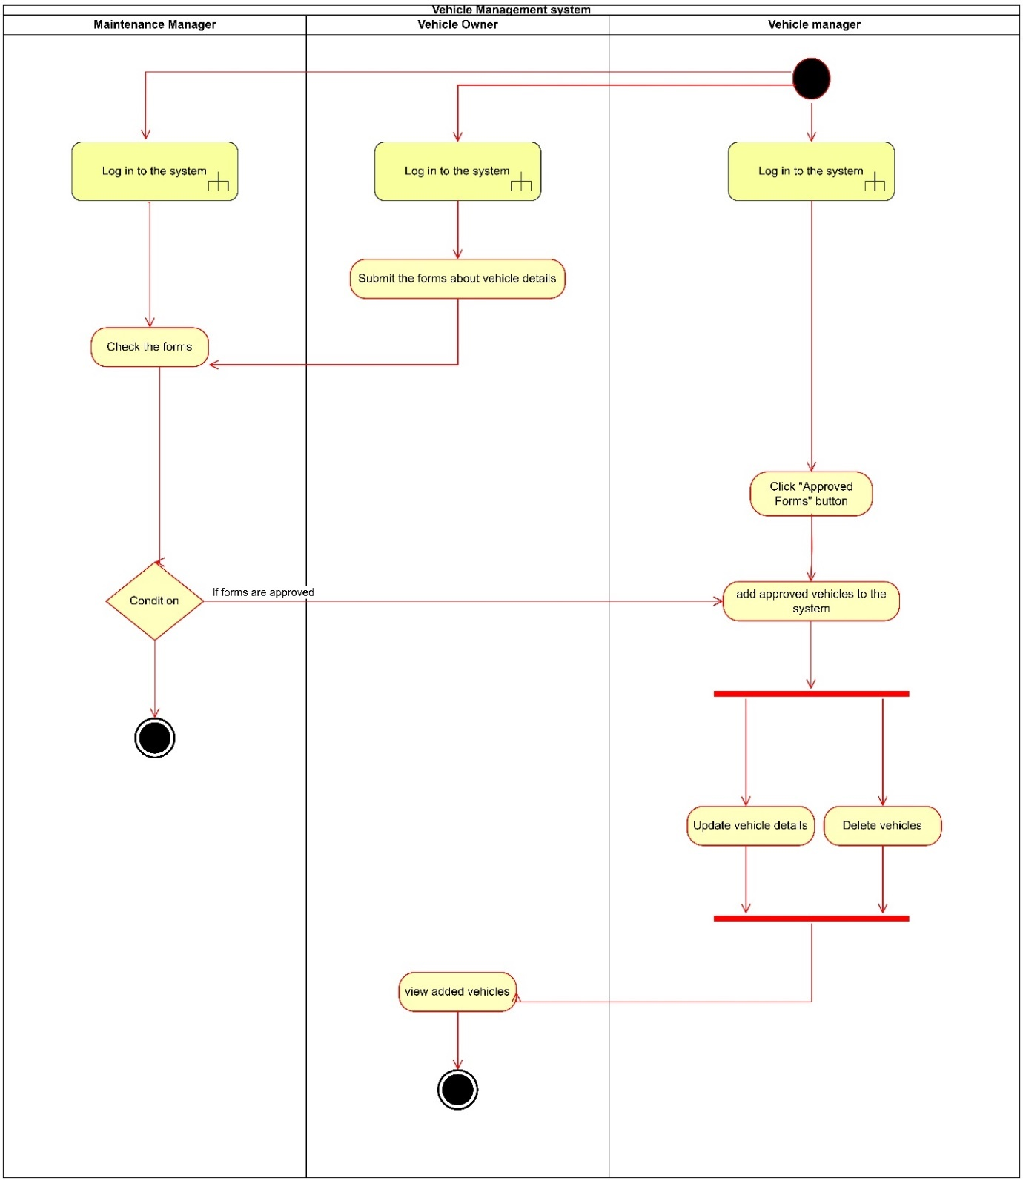

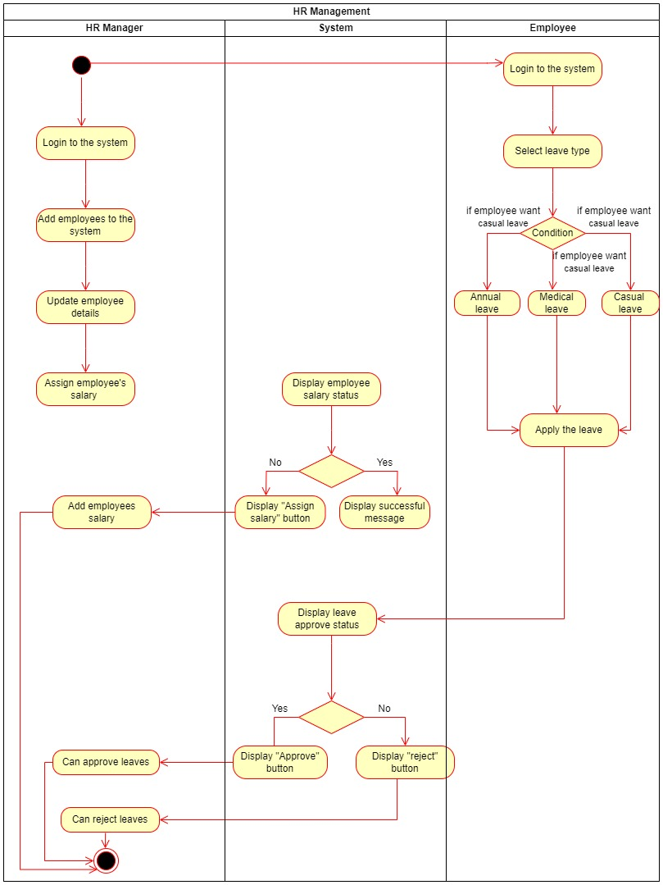

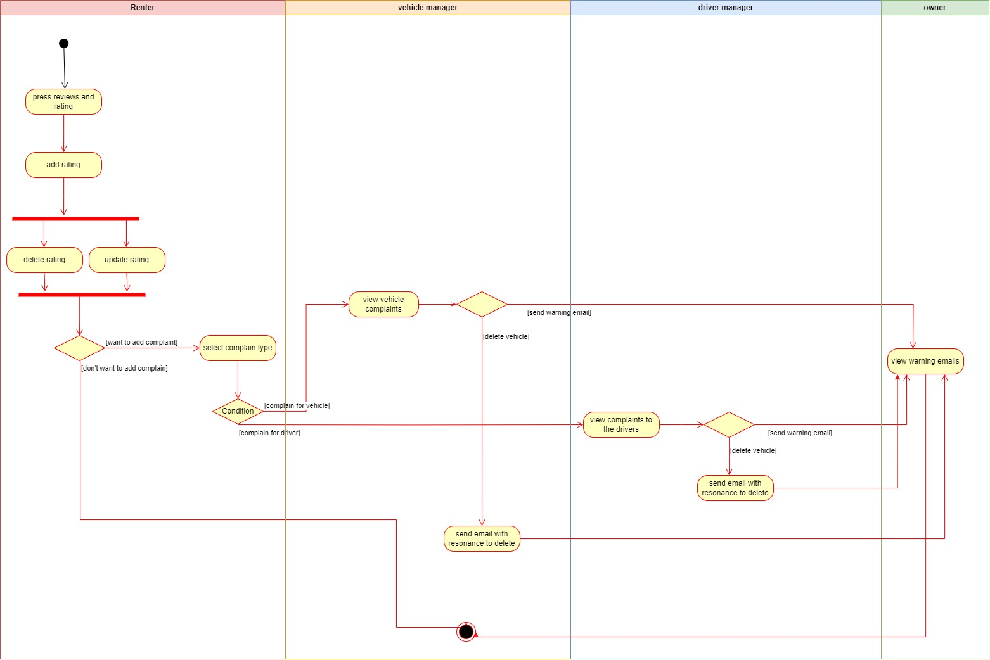 Reviews and Ratings Management system

Maintenance Management system 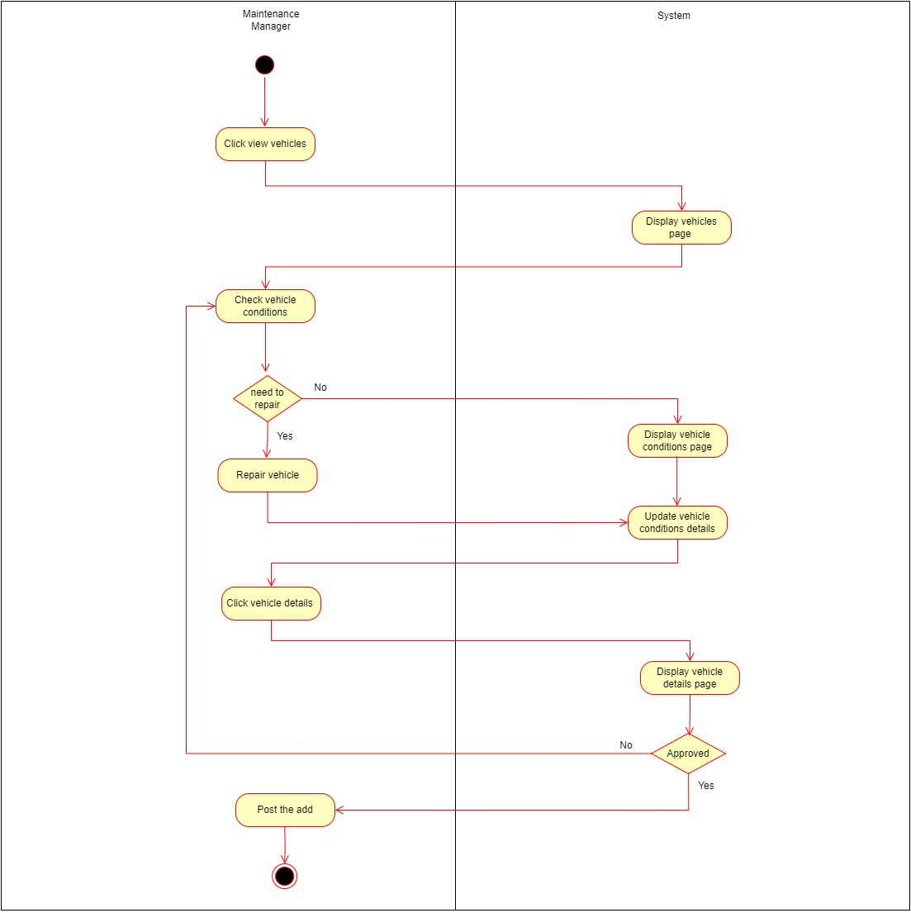

## 

## 2.2 Design

### 2.2.1 High Level Architecture Diagram

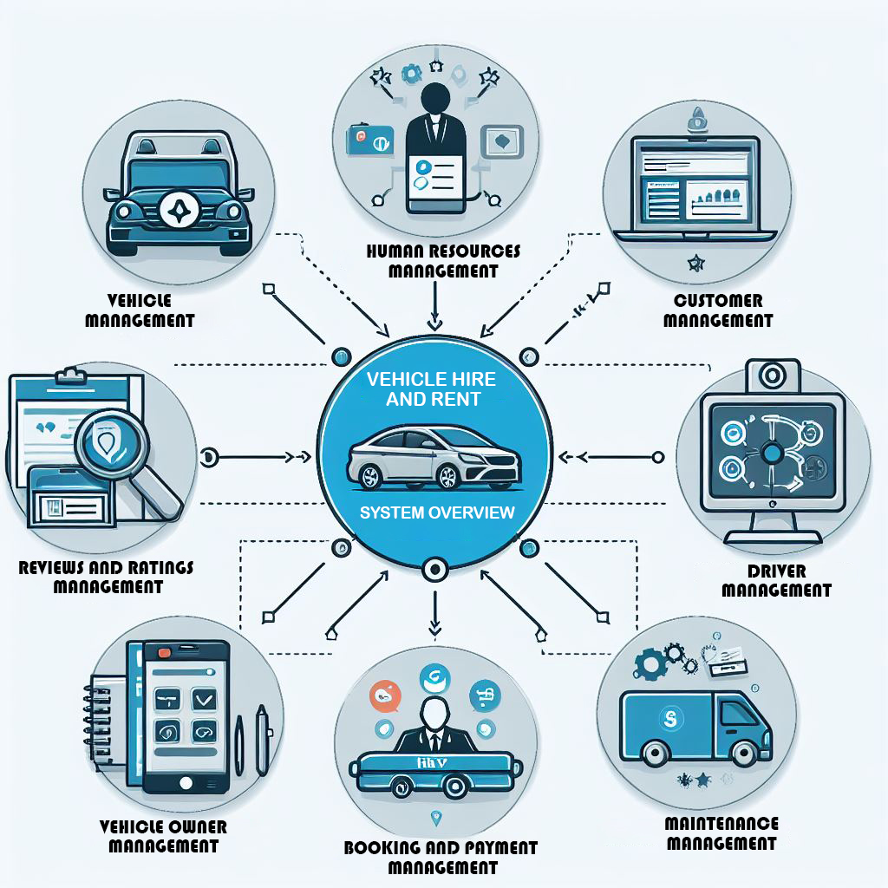

### 2.2.2 ER Diagram

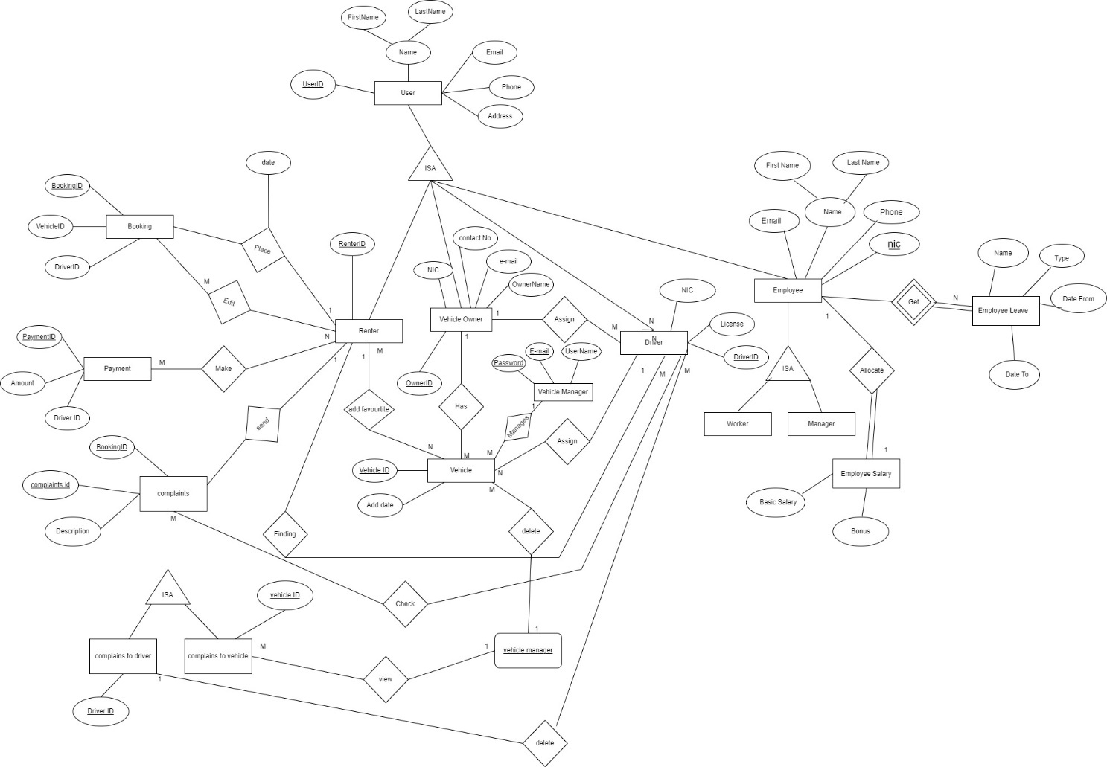

### 

### 2.2.3 Class Diagram

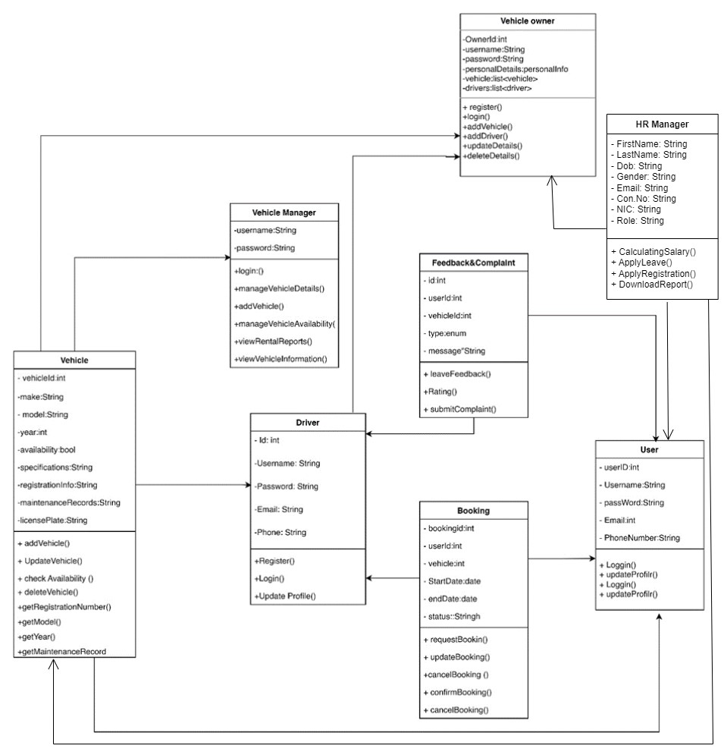

### 2.2.4 Sequence Diagrams

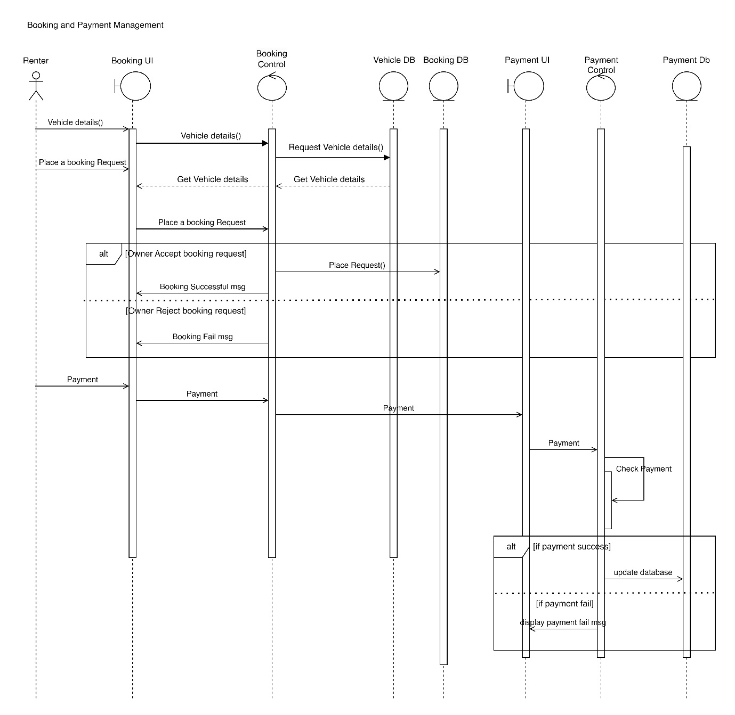

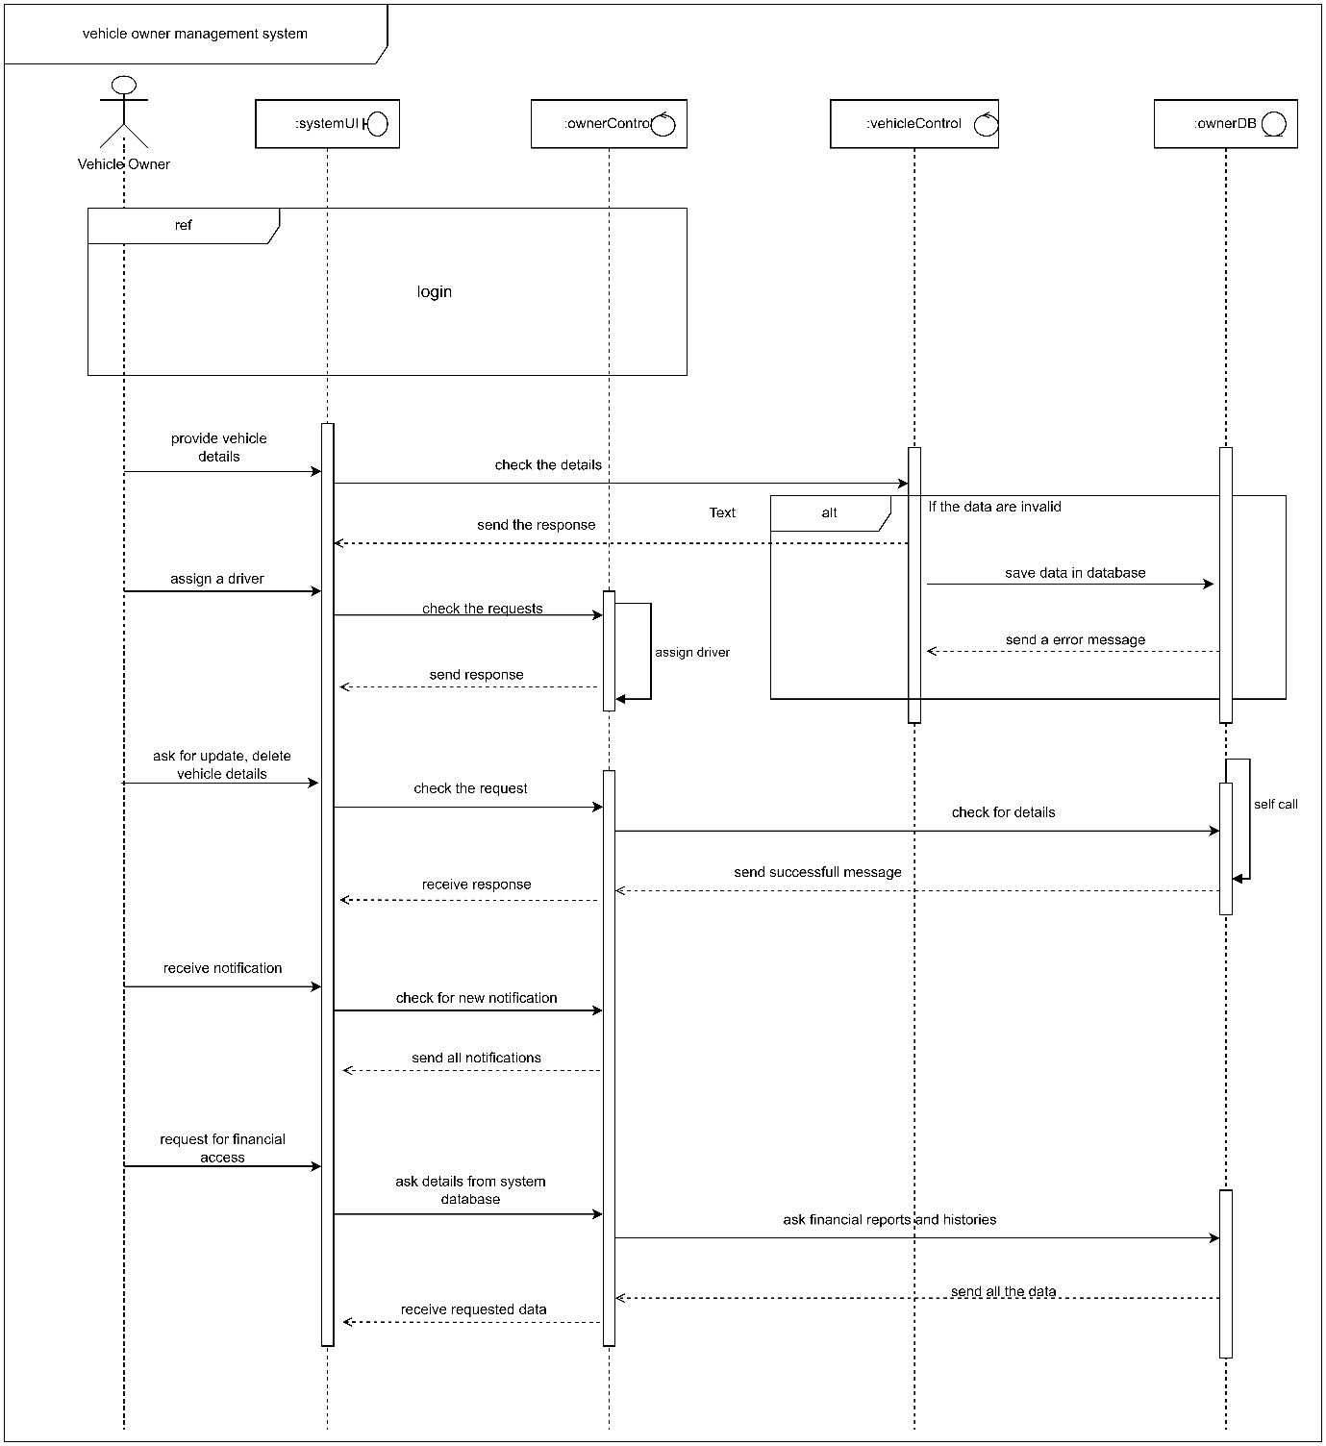

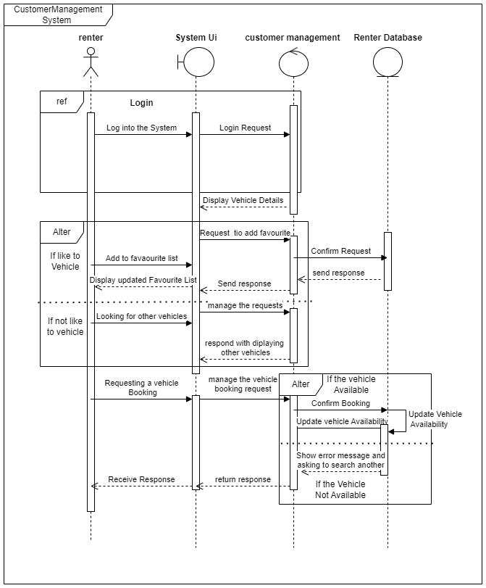

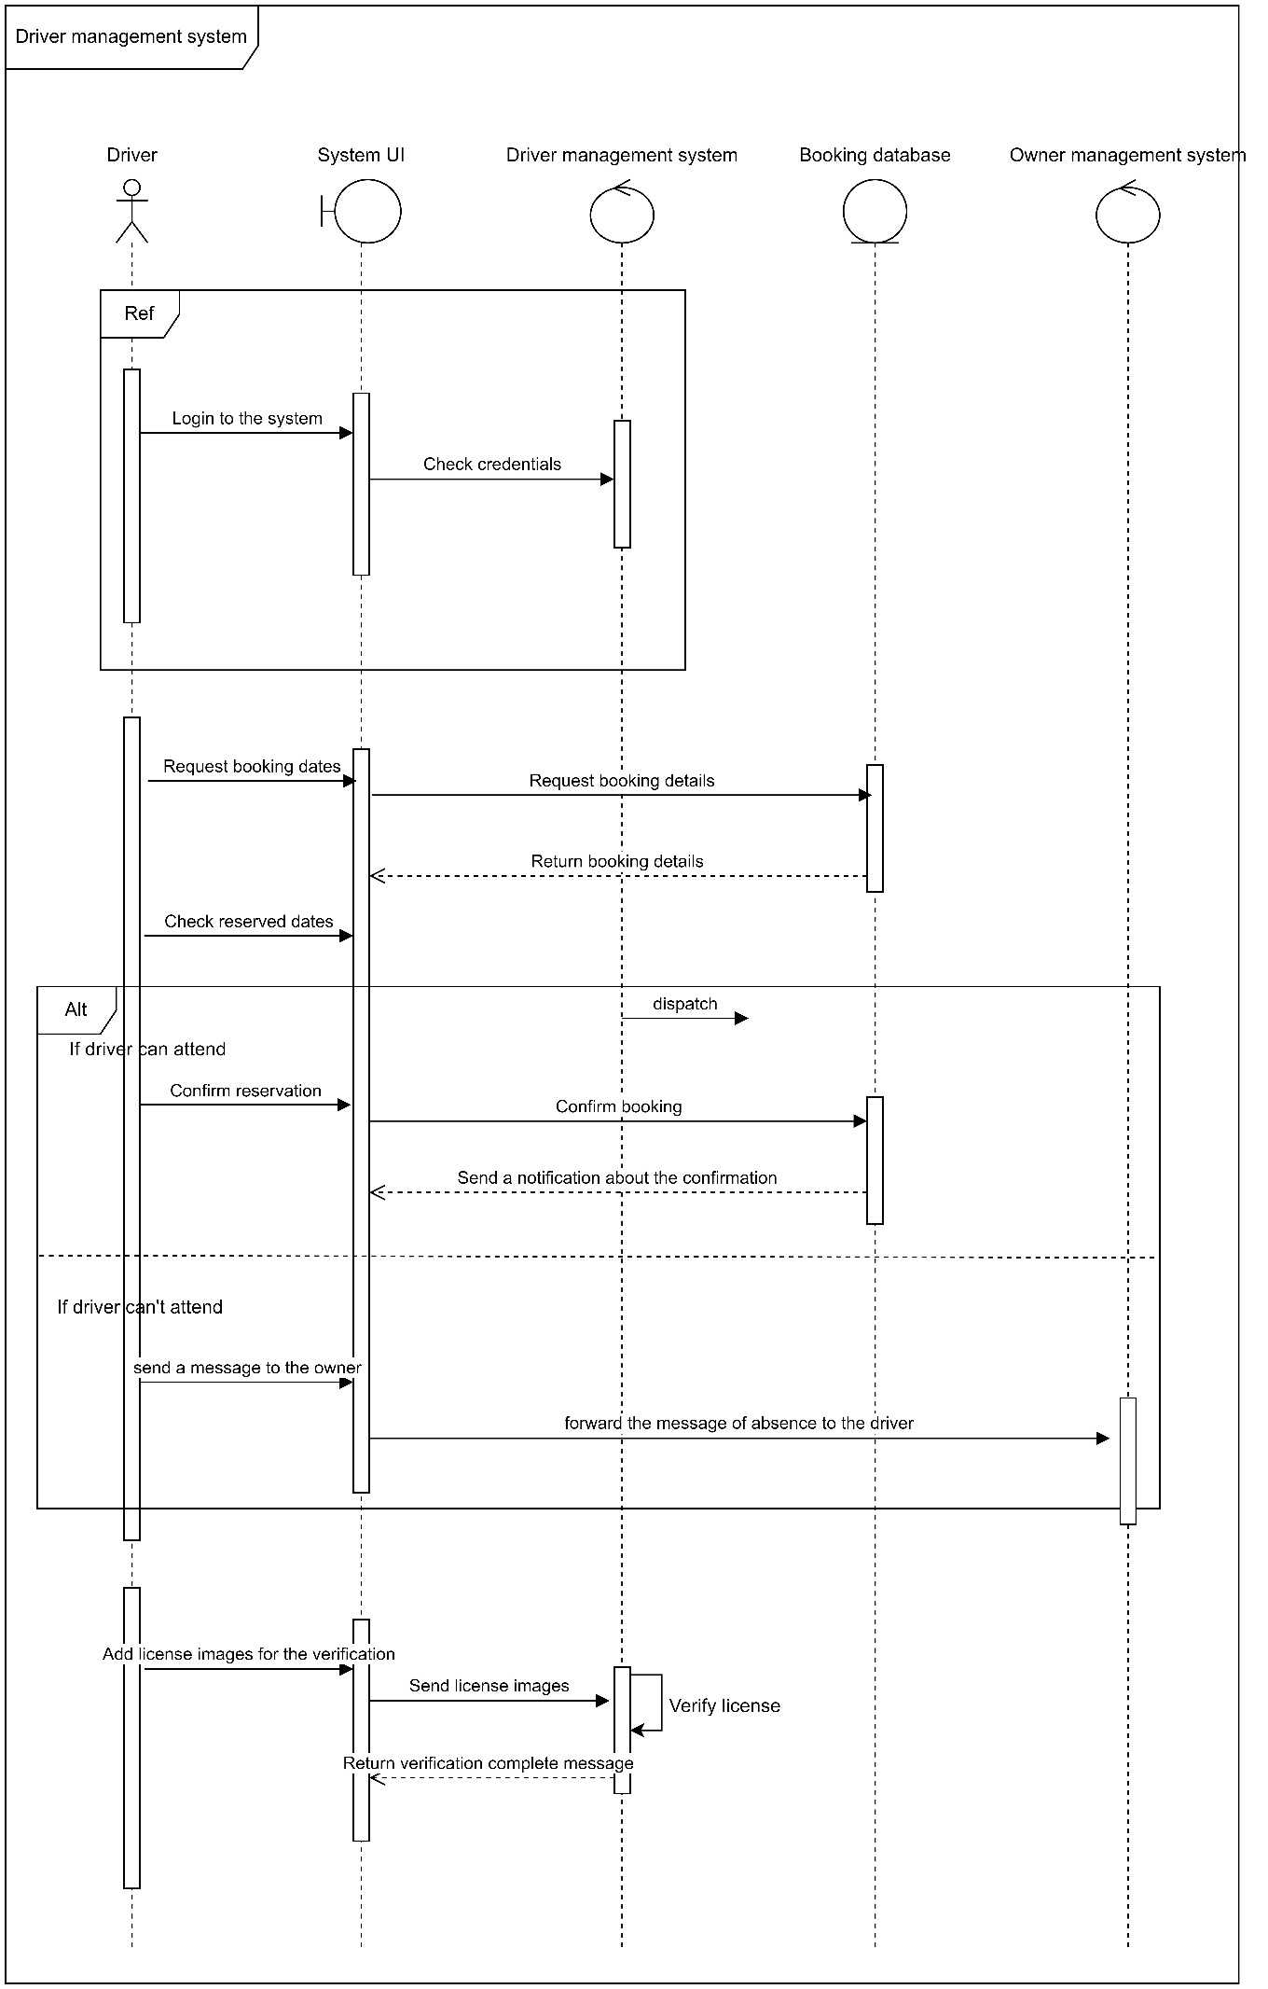

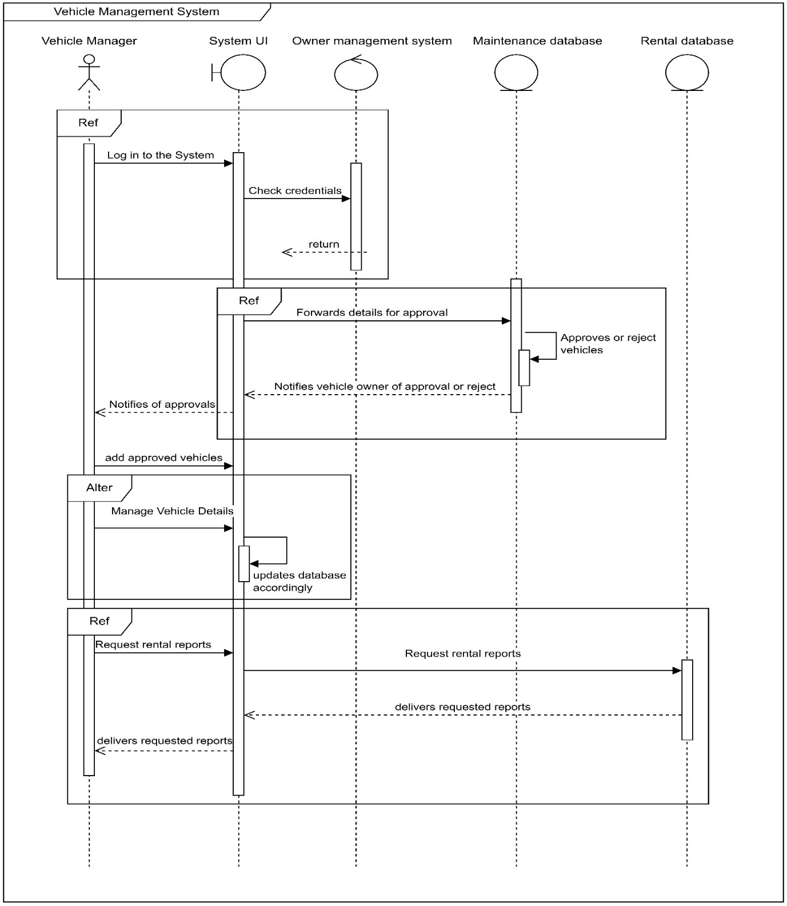

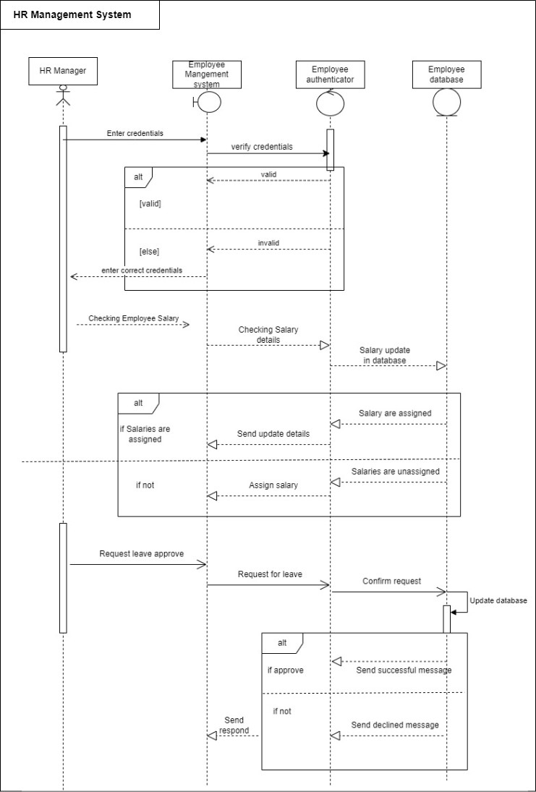

Reviews and Ratings Management System

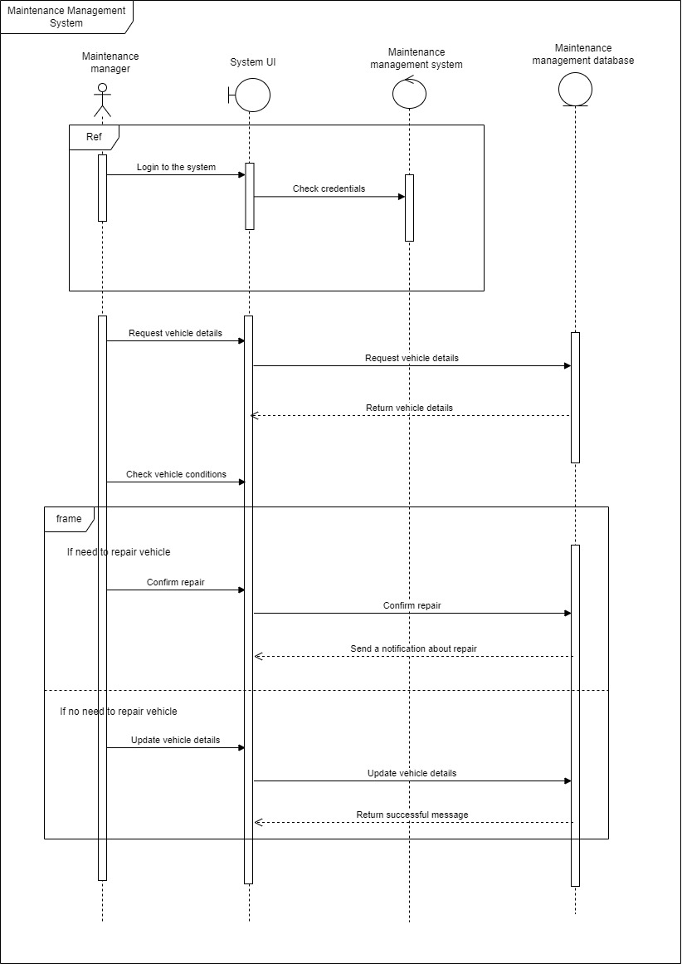

### 2.2.5 Interfaces

#### Landing



Loging & Sign Up 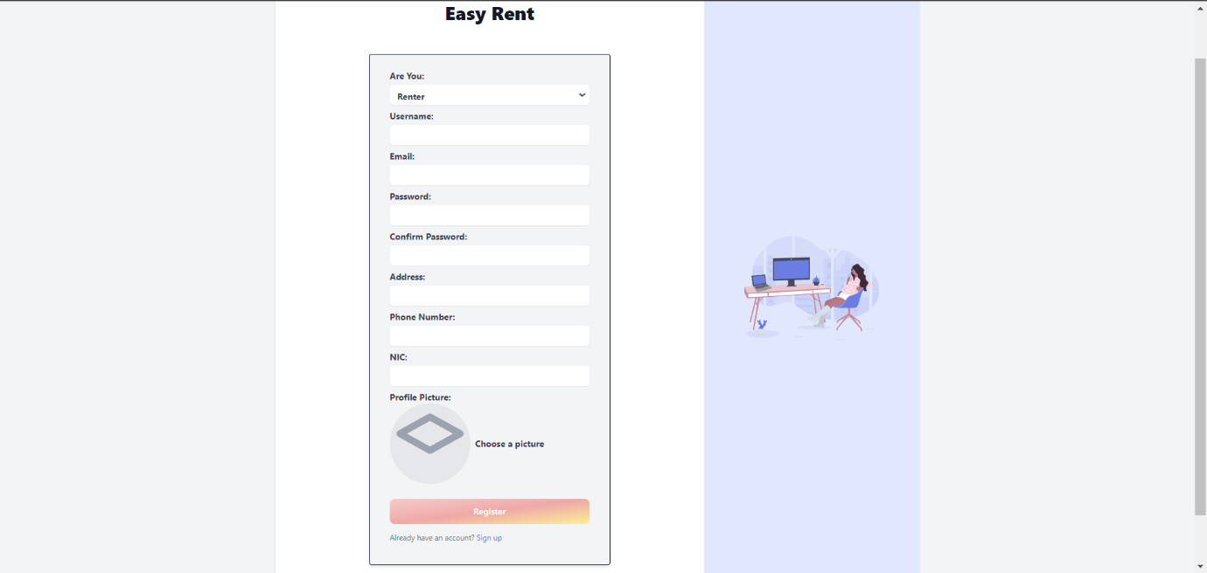

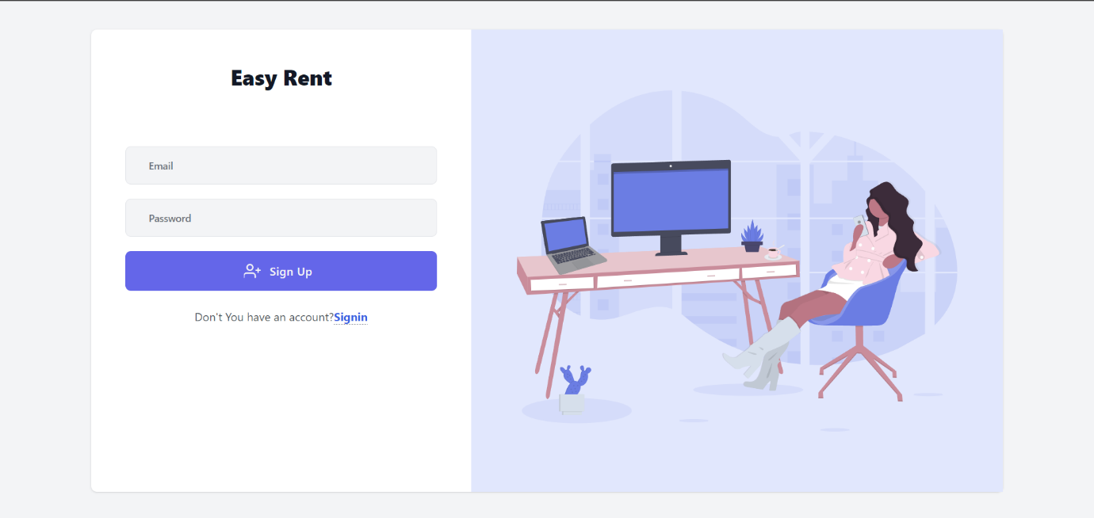

#### Home

#### Booking & Payment Management

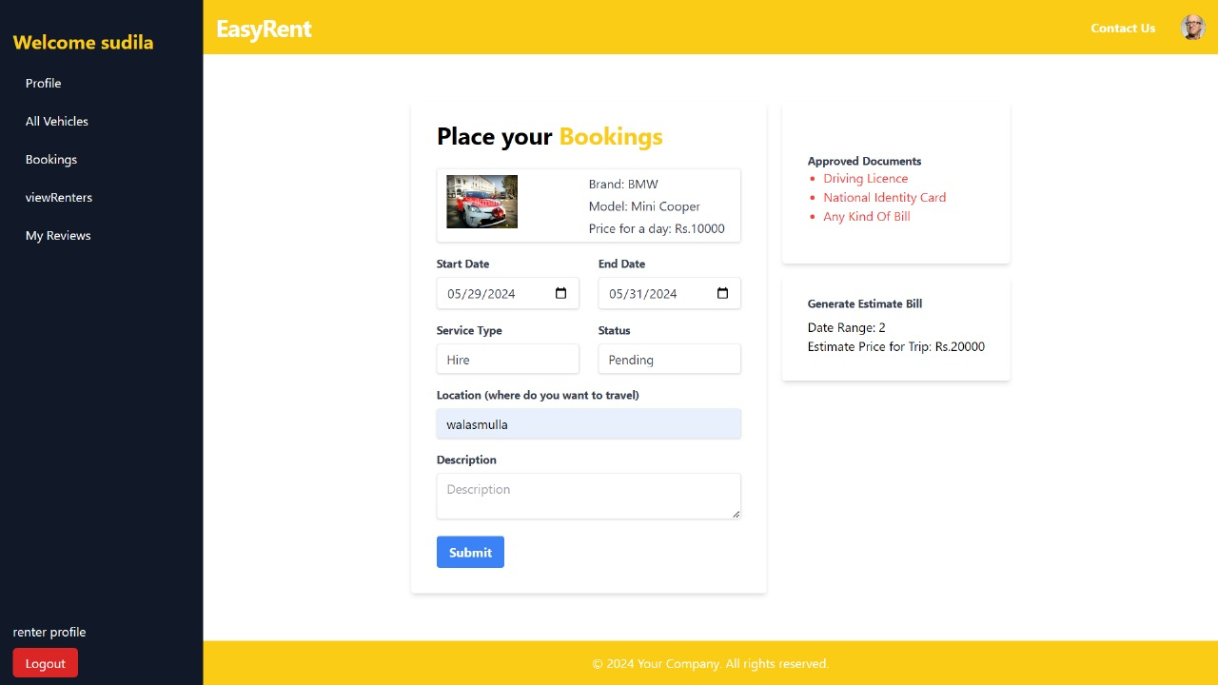

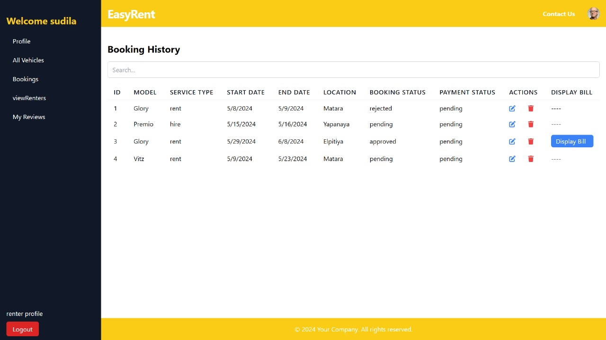

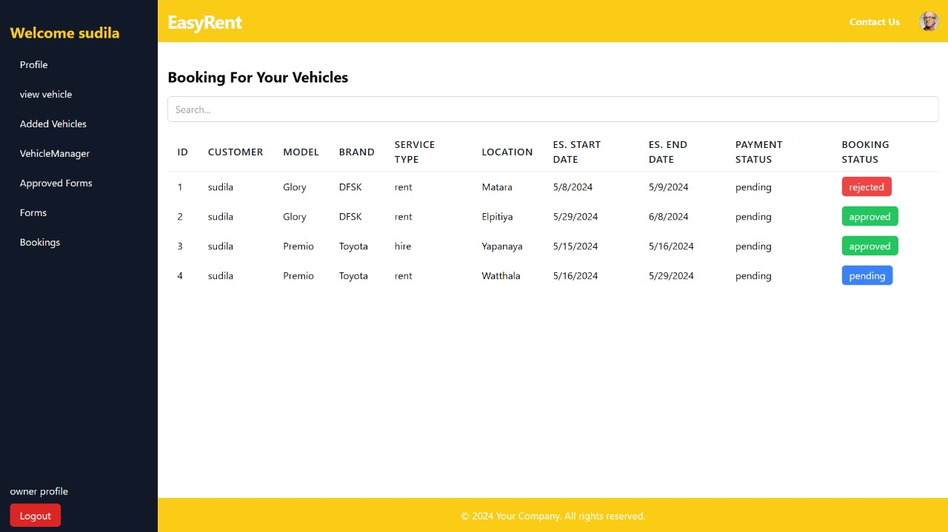

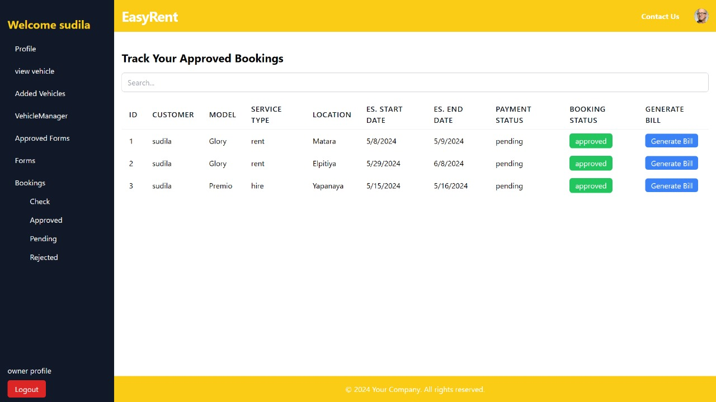

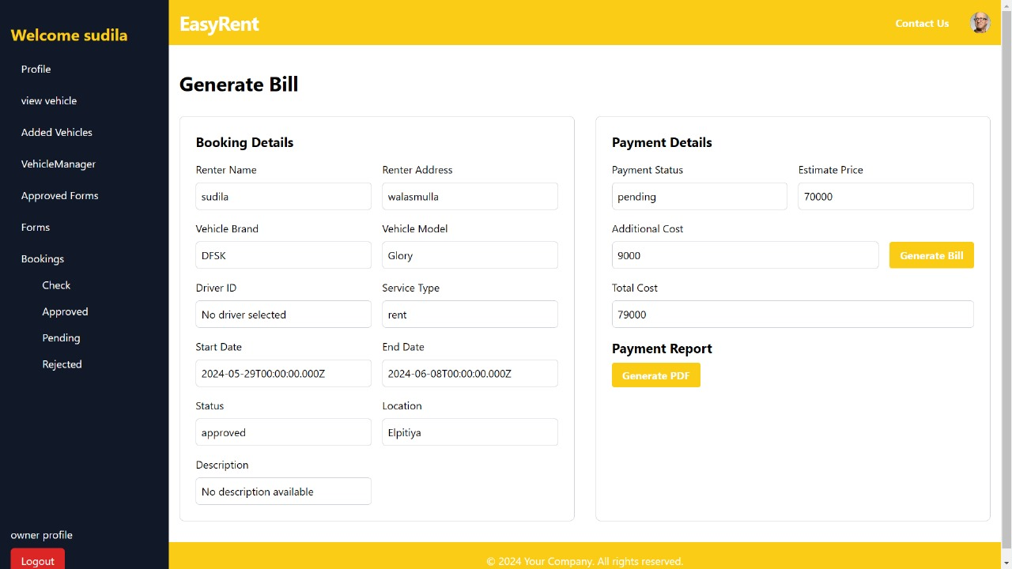

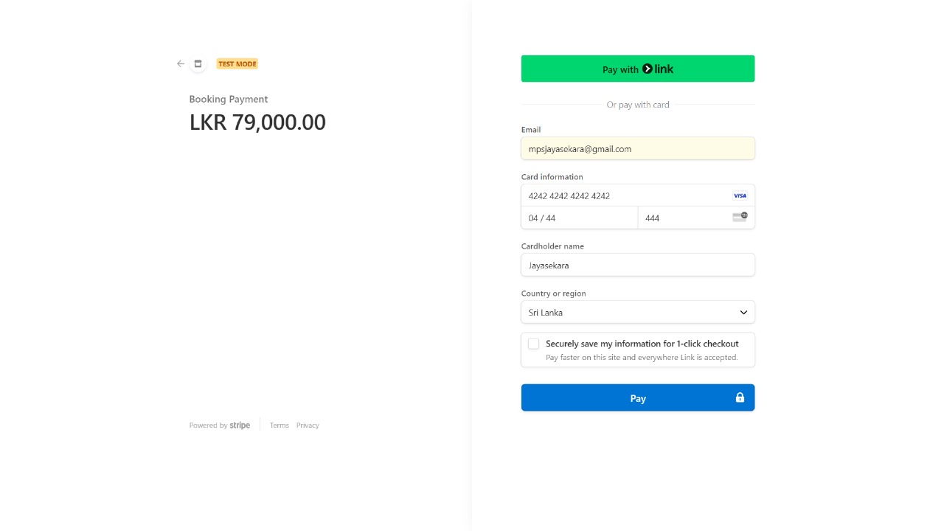

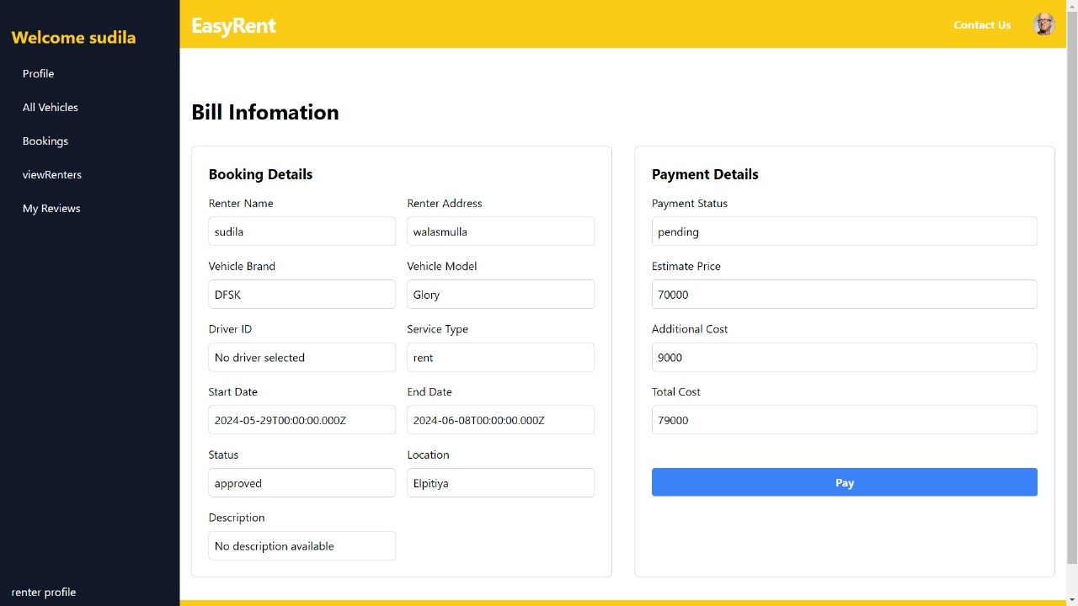

**Vehicle Owner Management System**

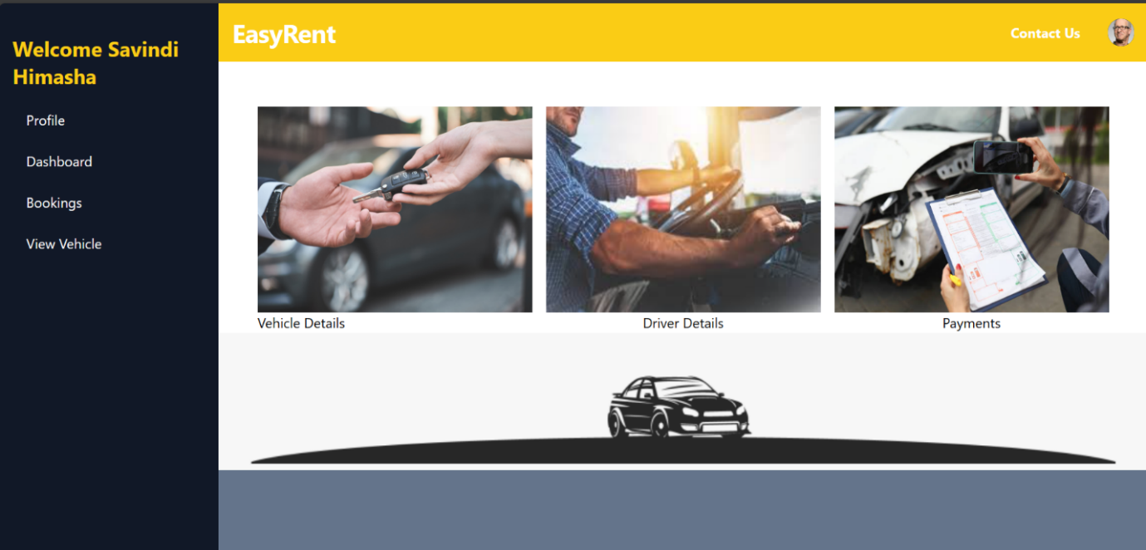

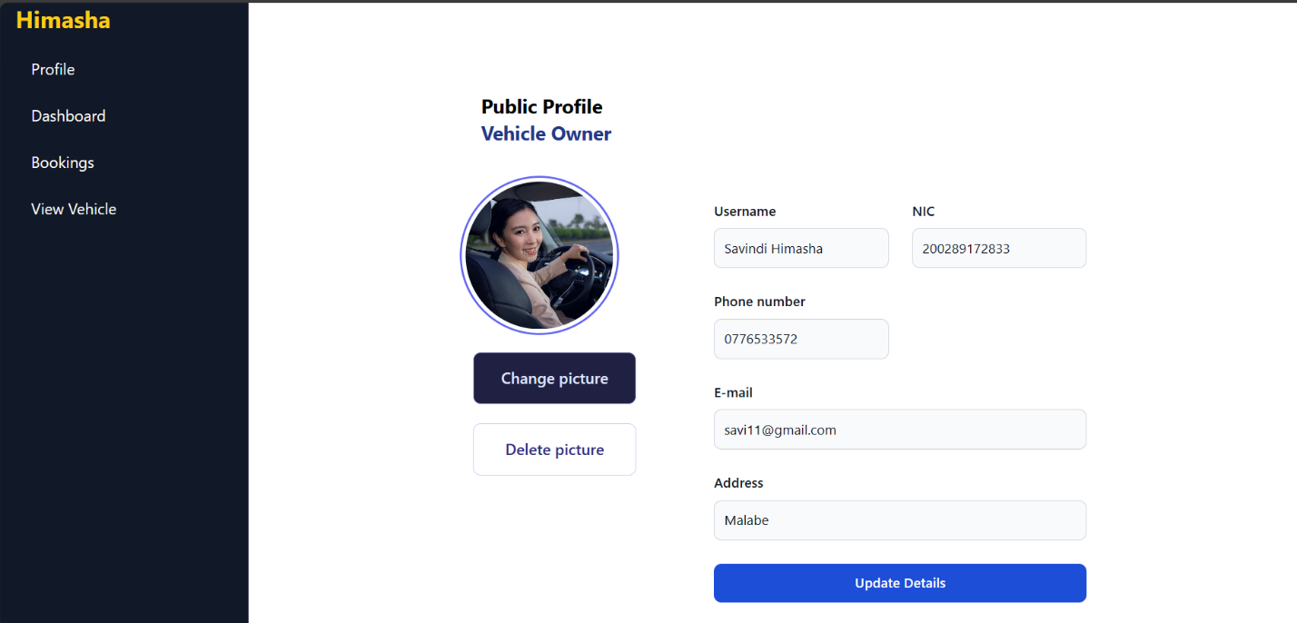

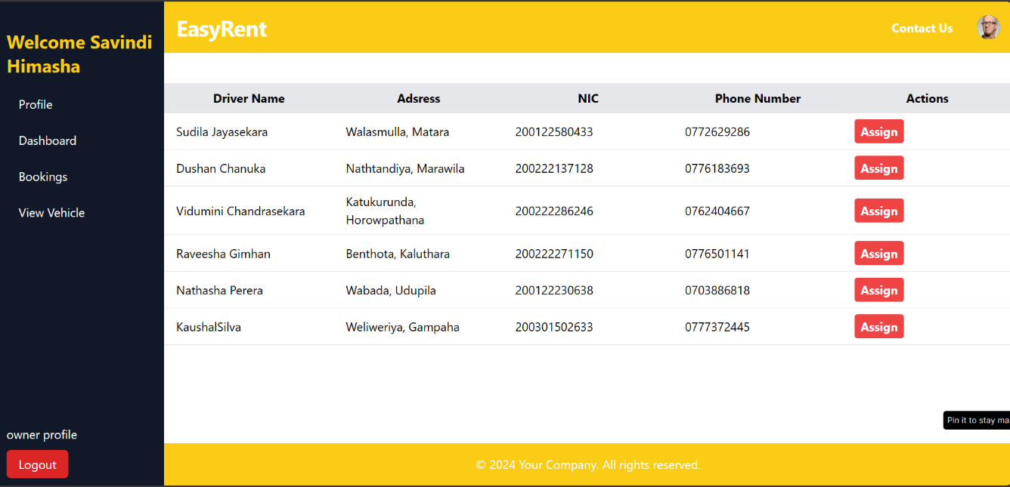

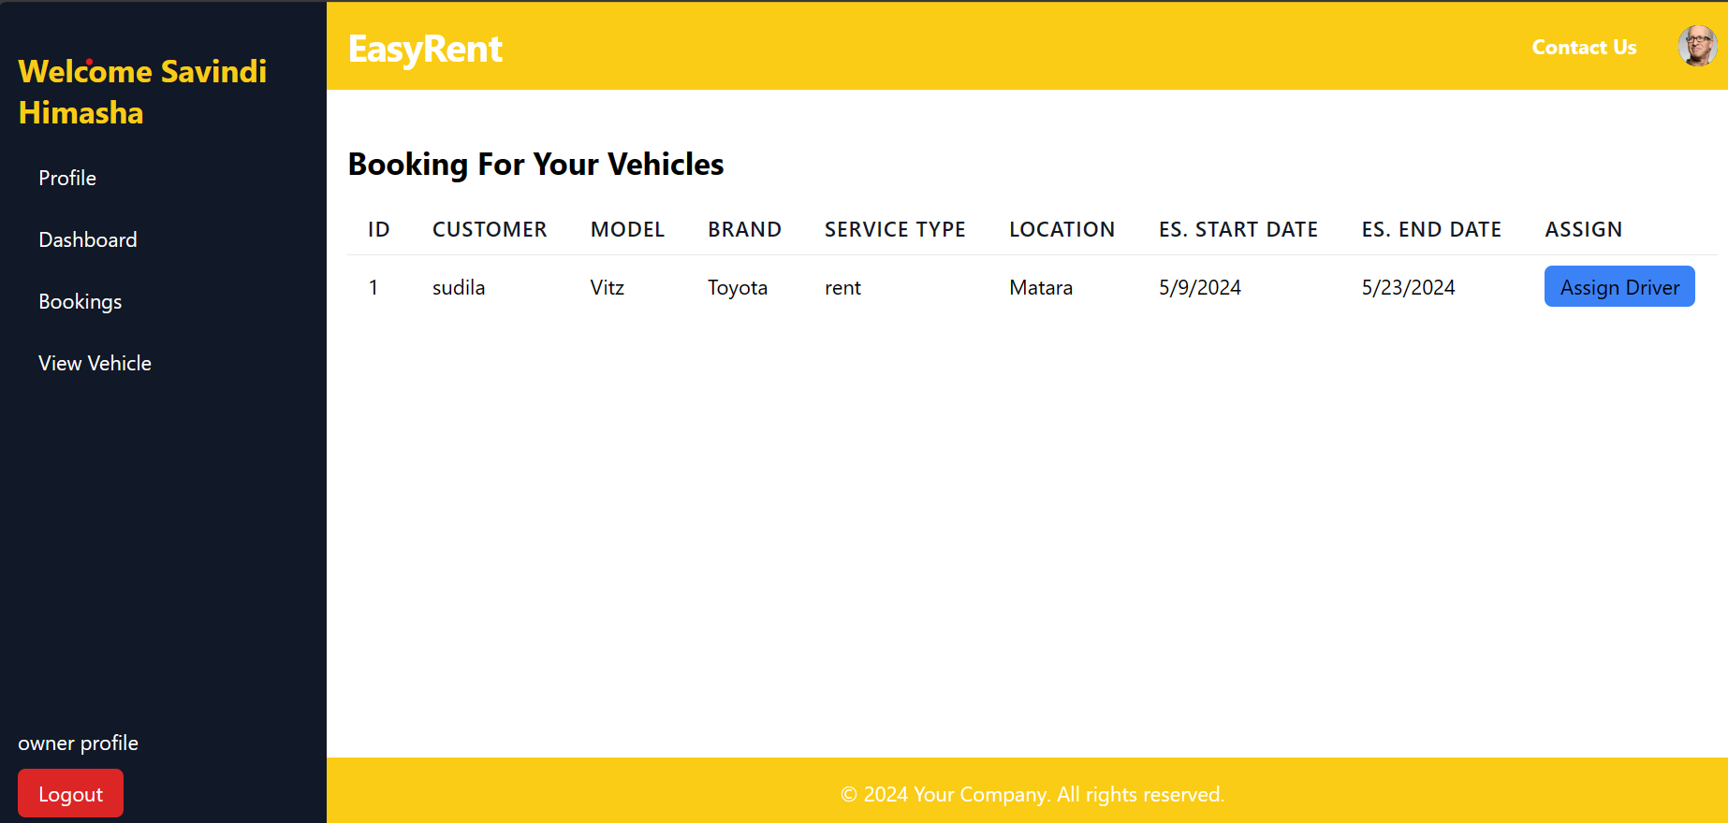

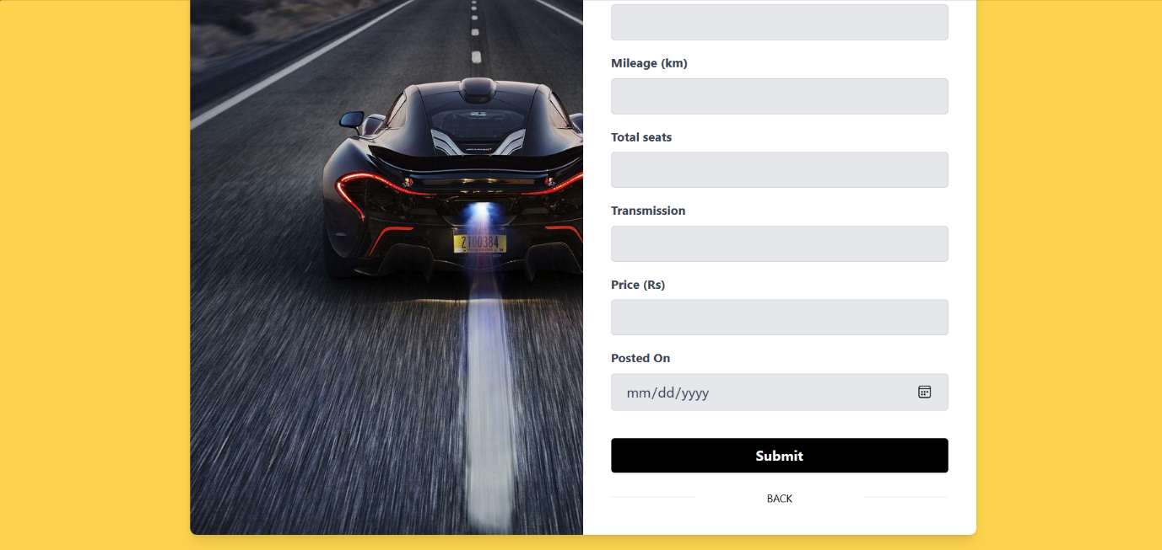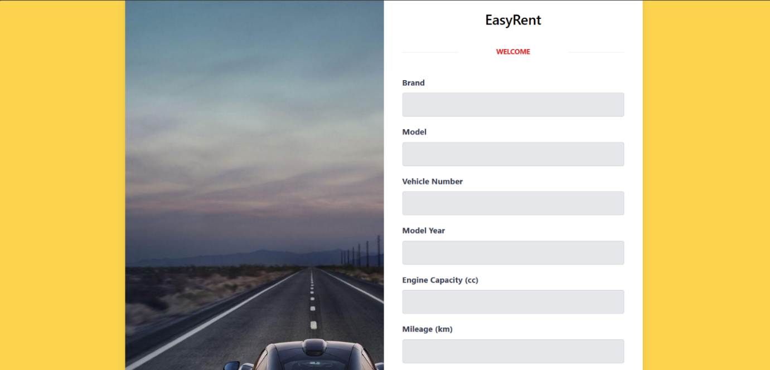

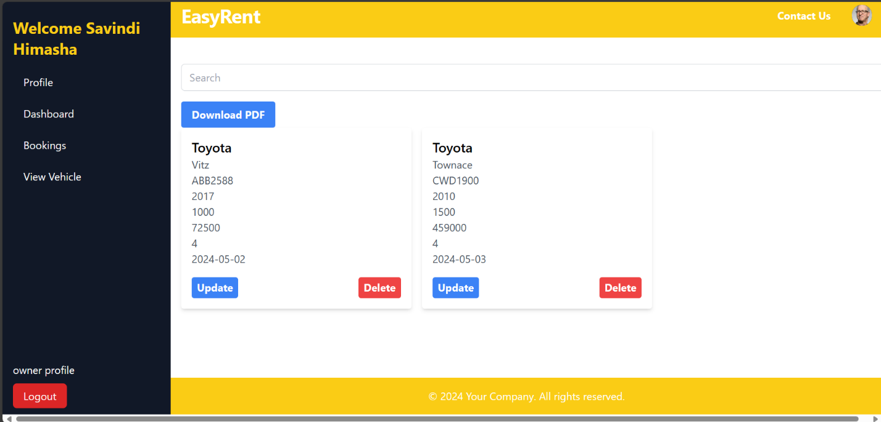

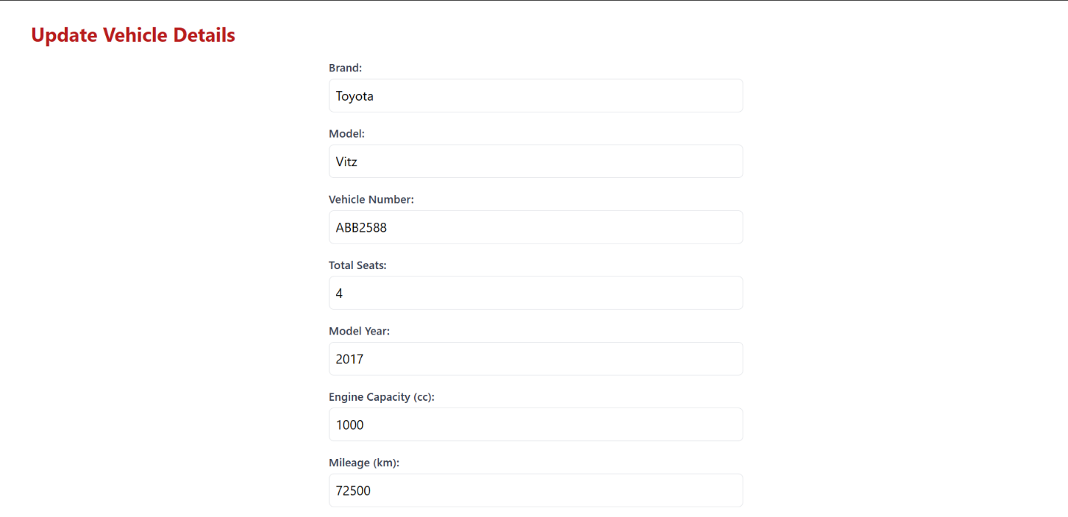

**Renter Management System**

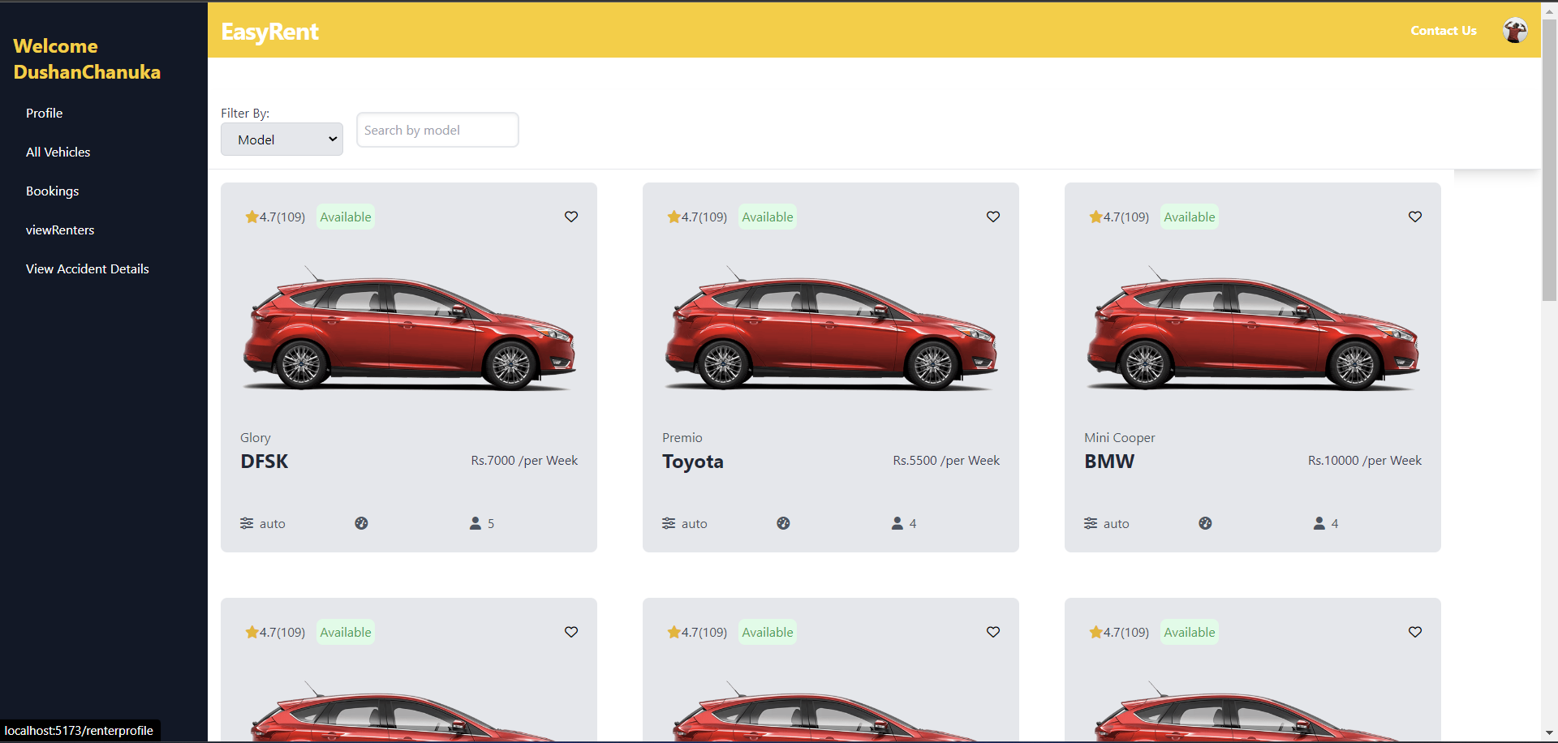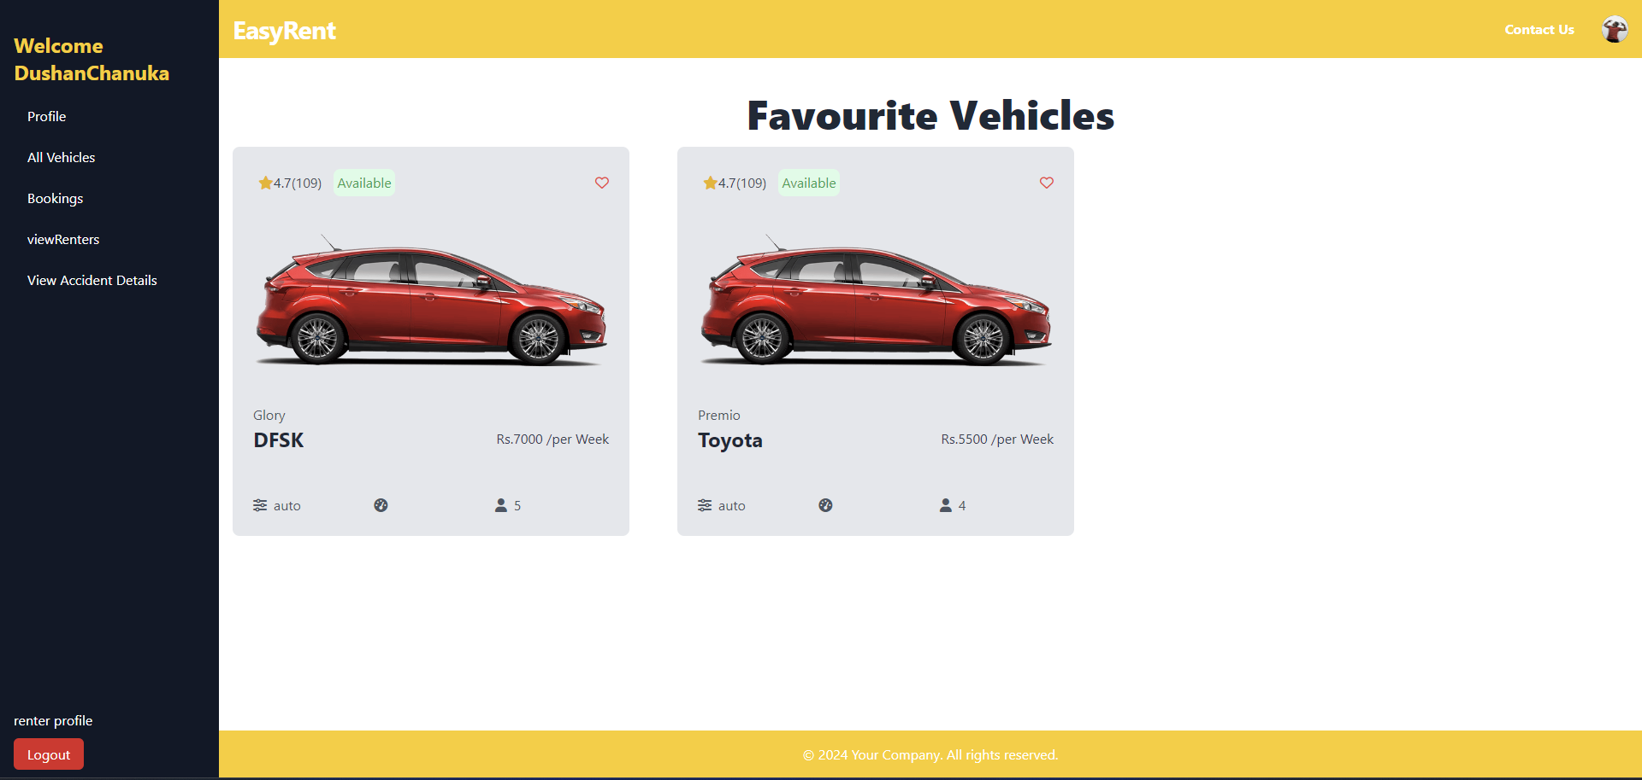

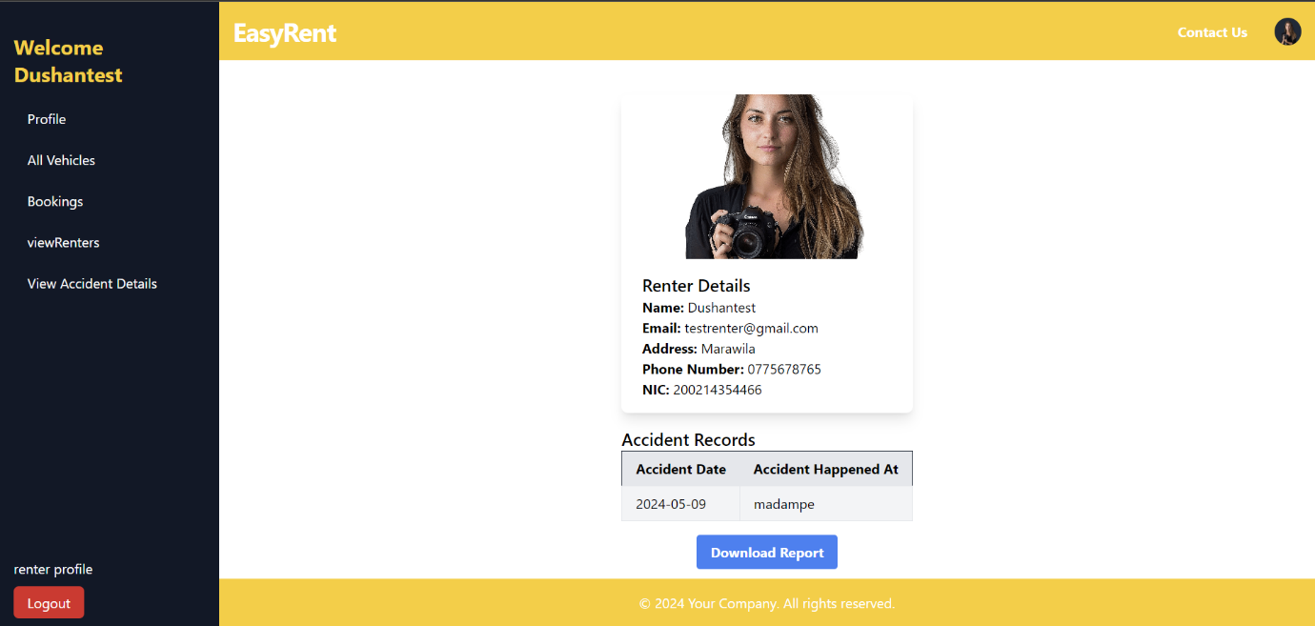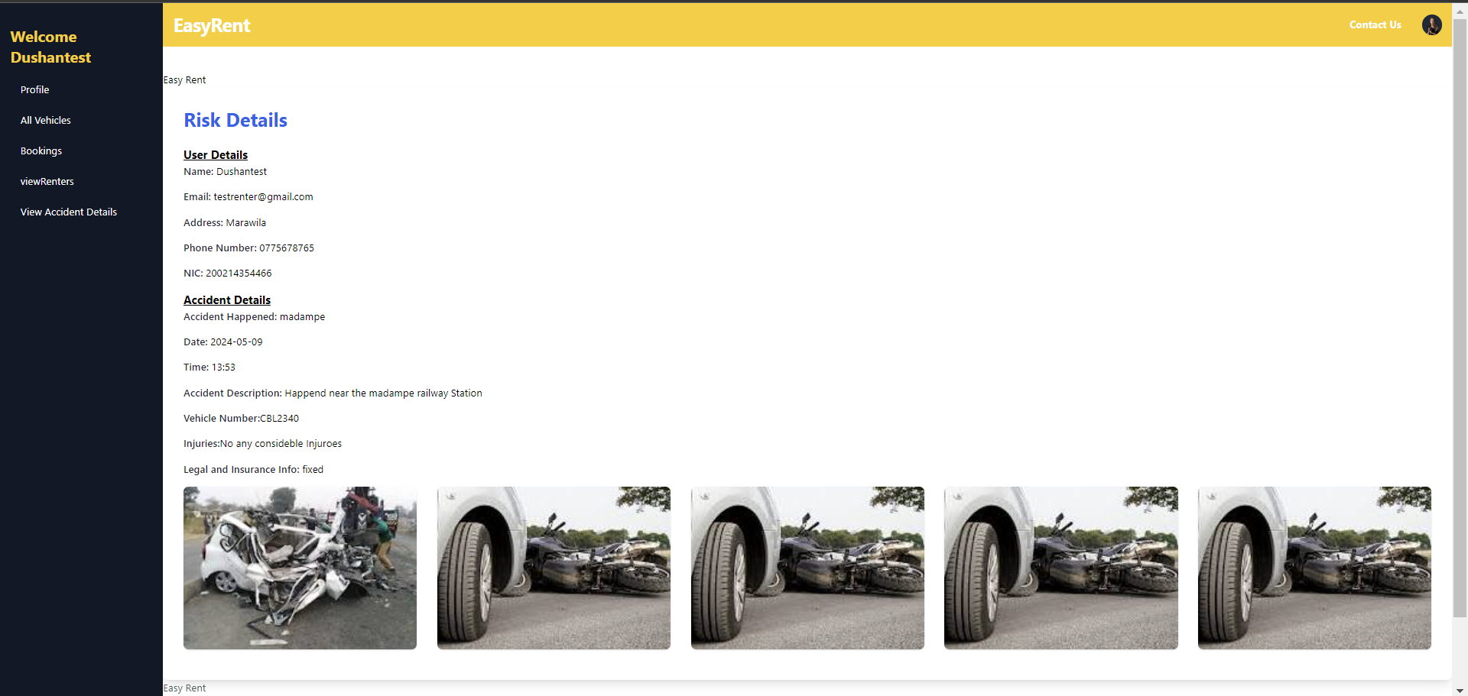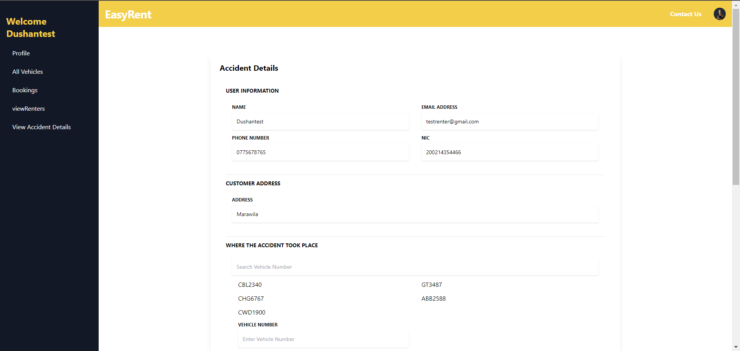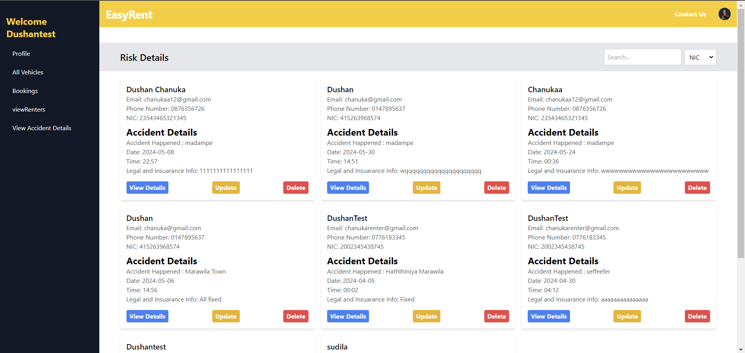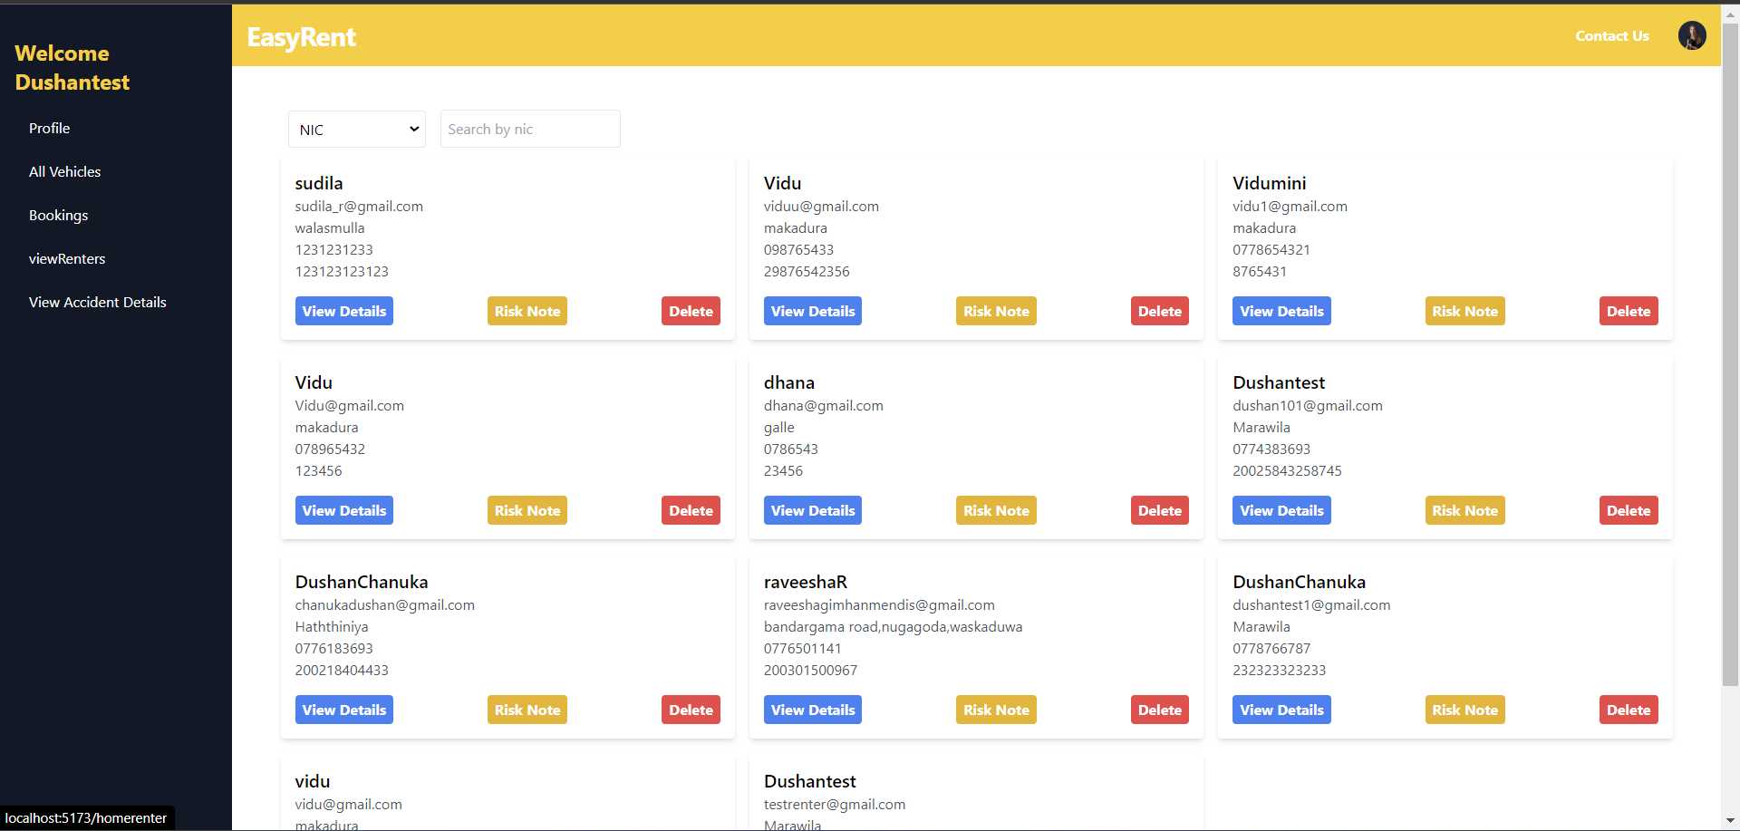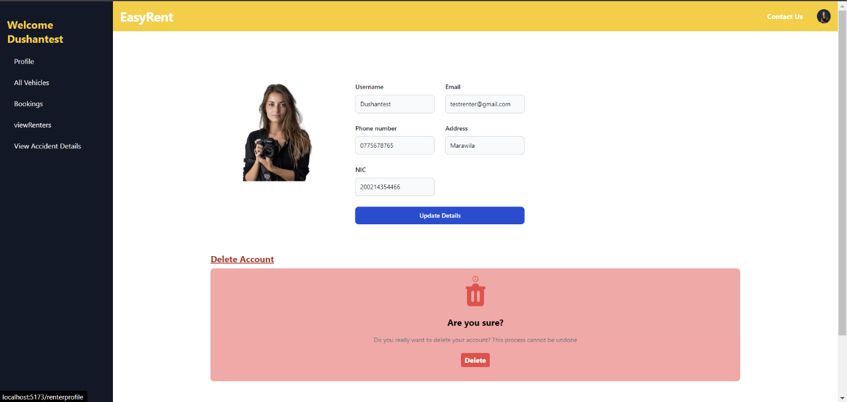

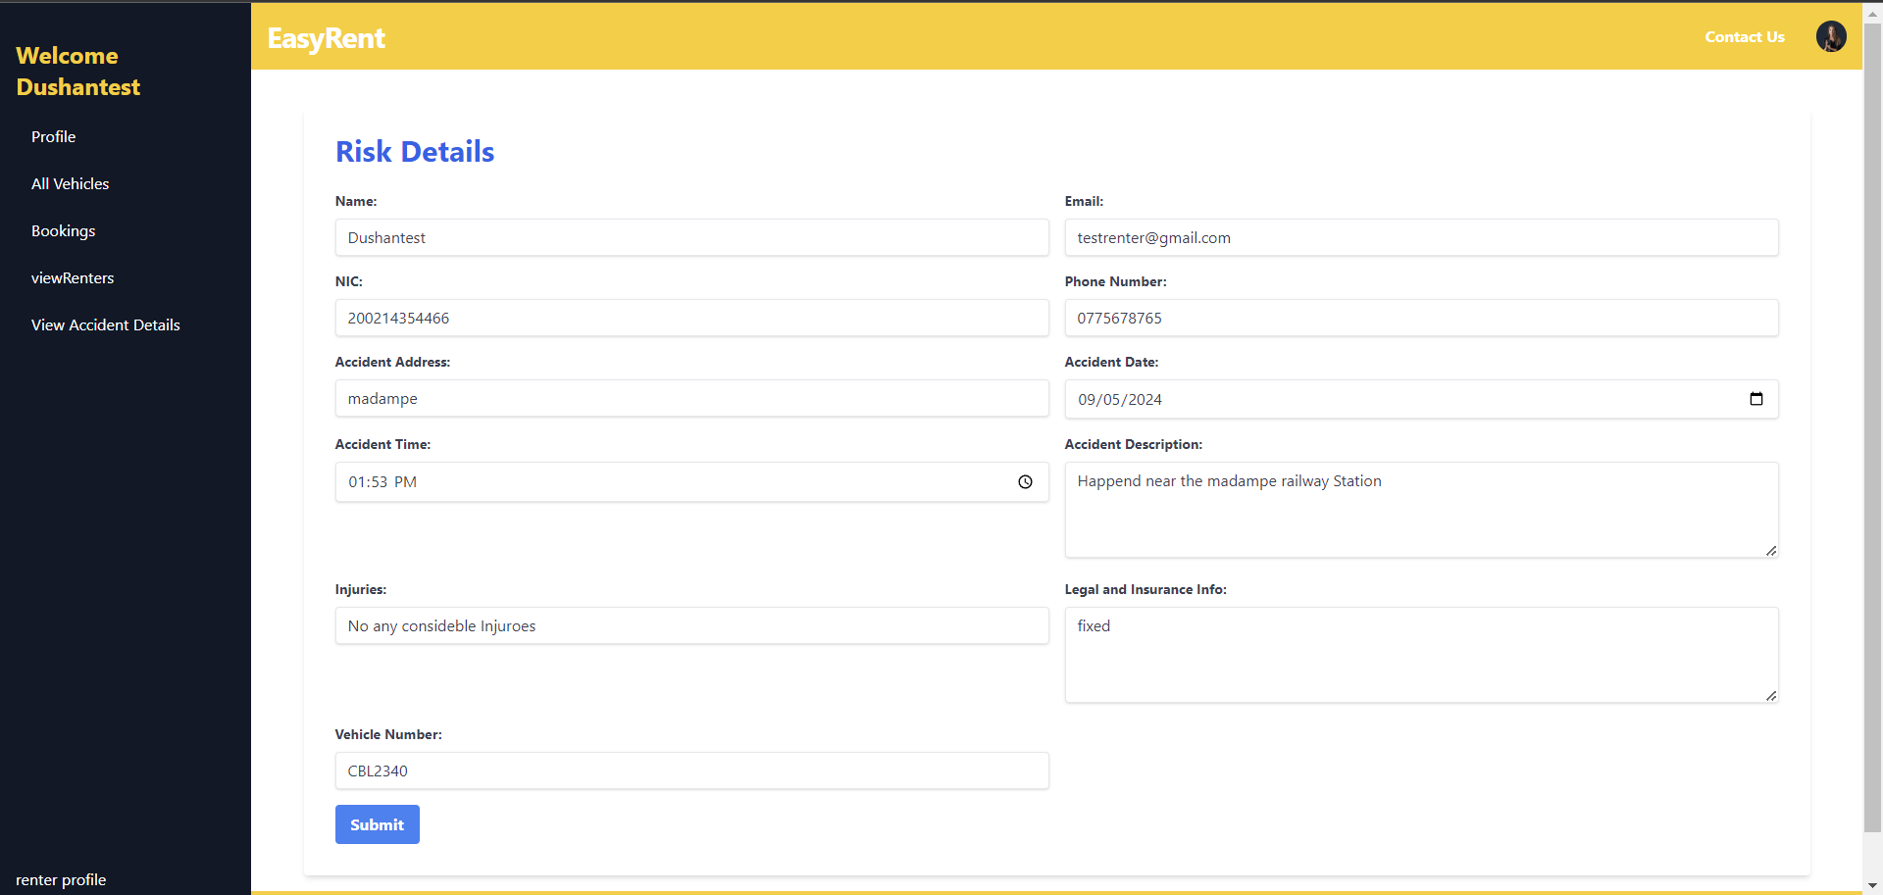

**Driver Management System**

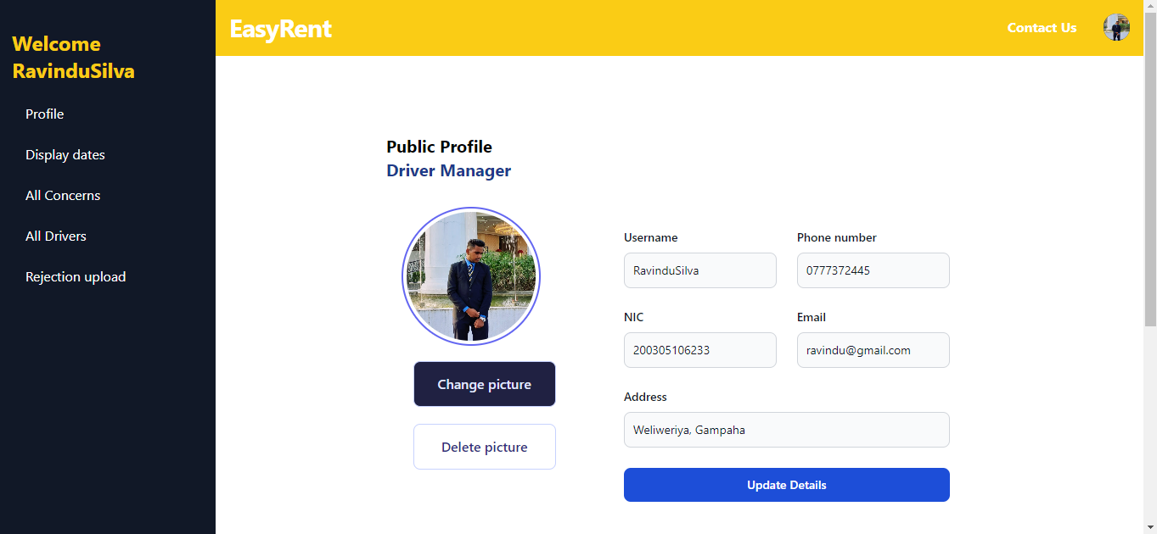

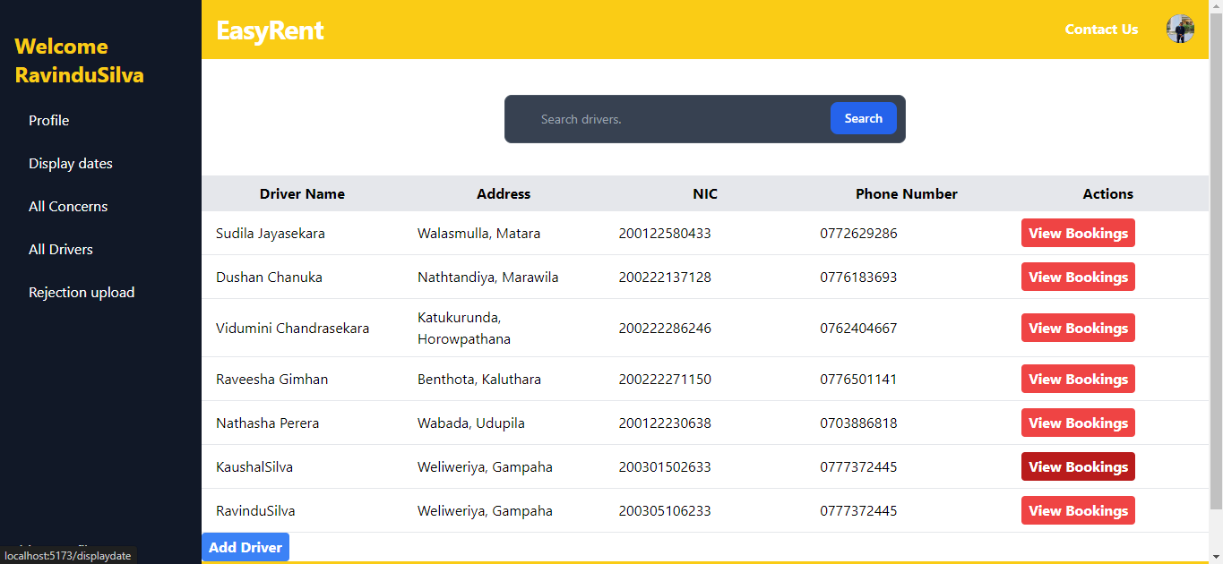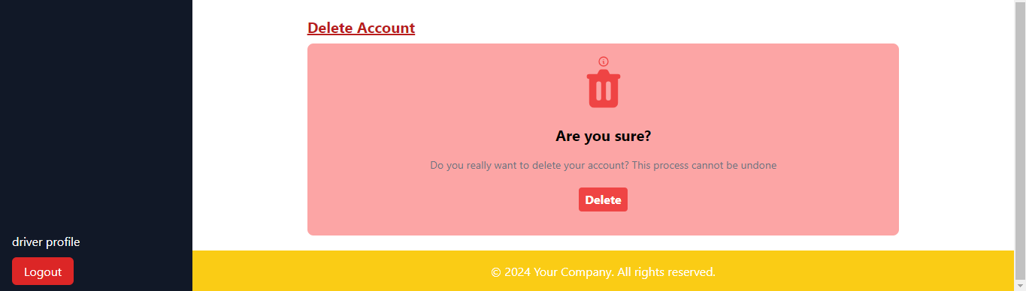

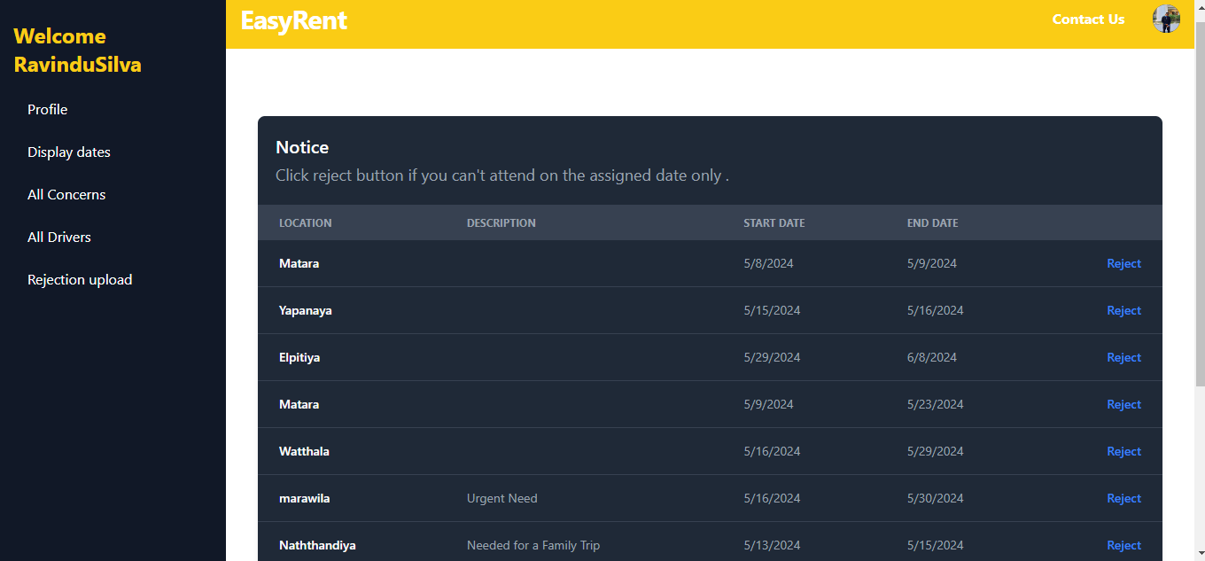

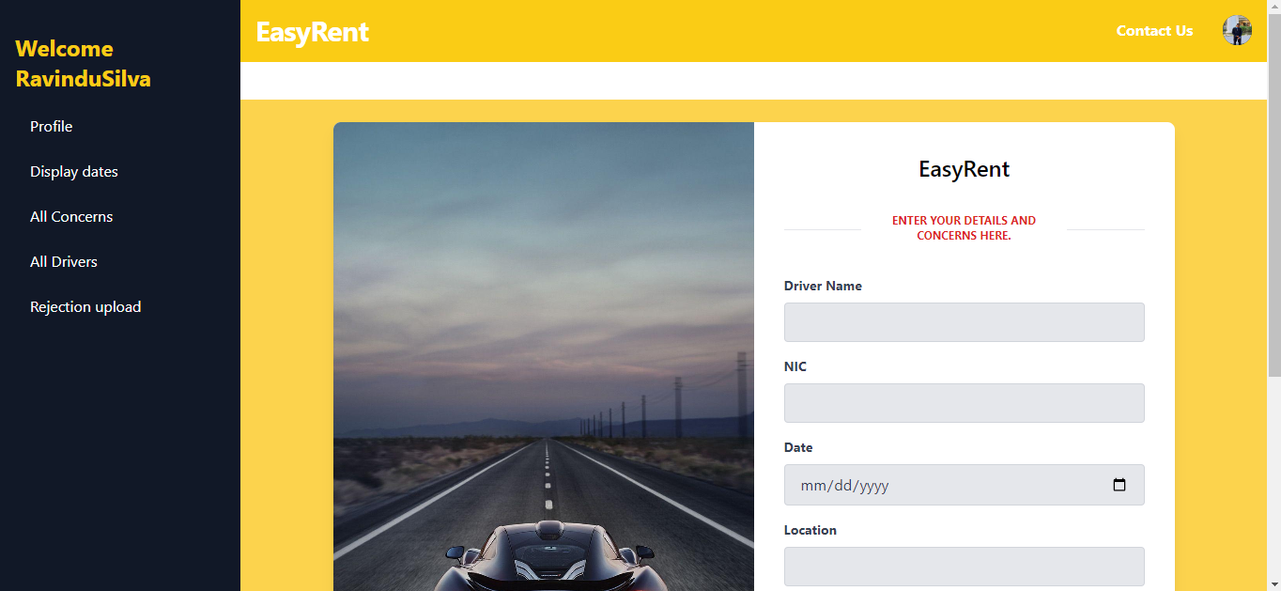

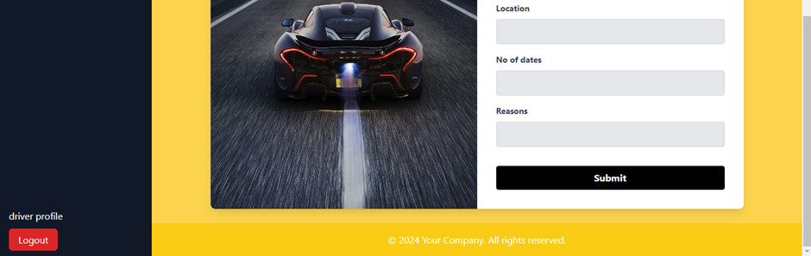

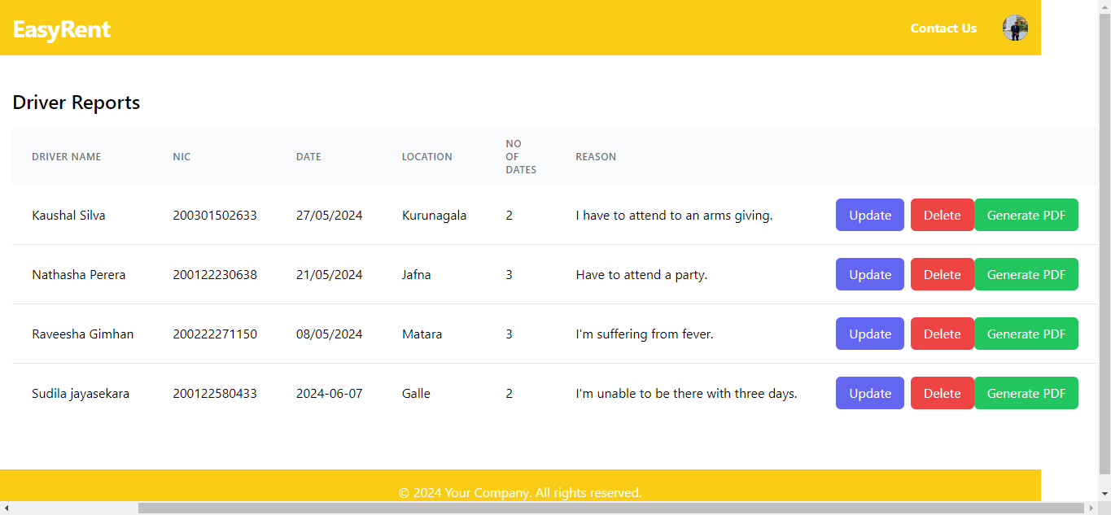

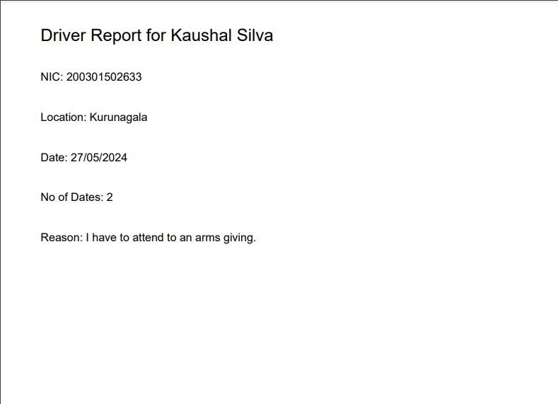

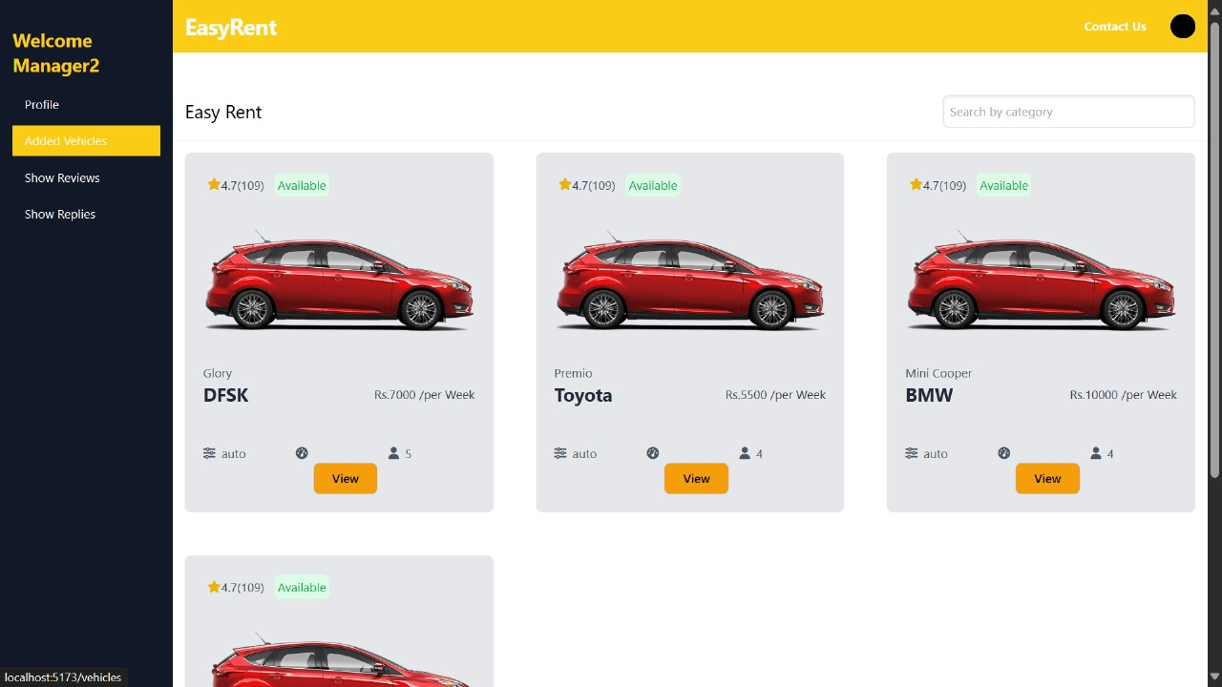**Vehicle Management System**

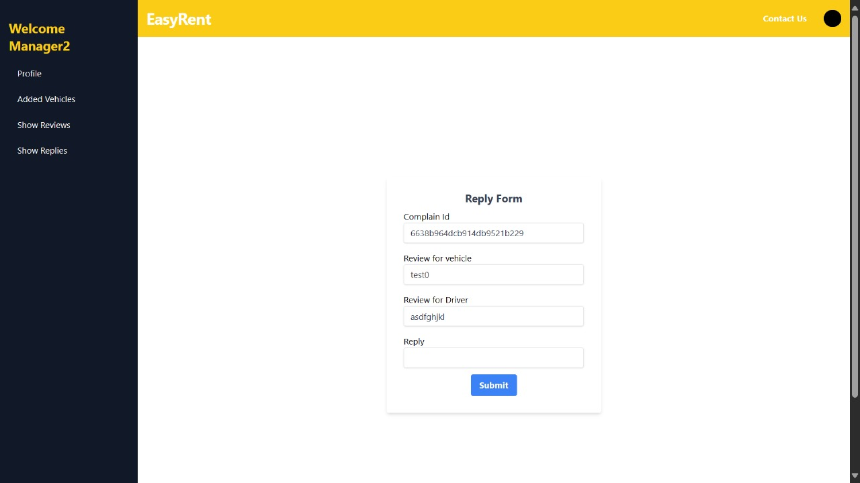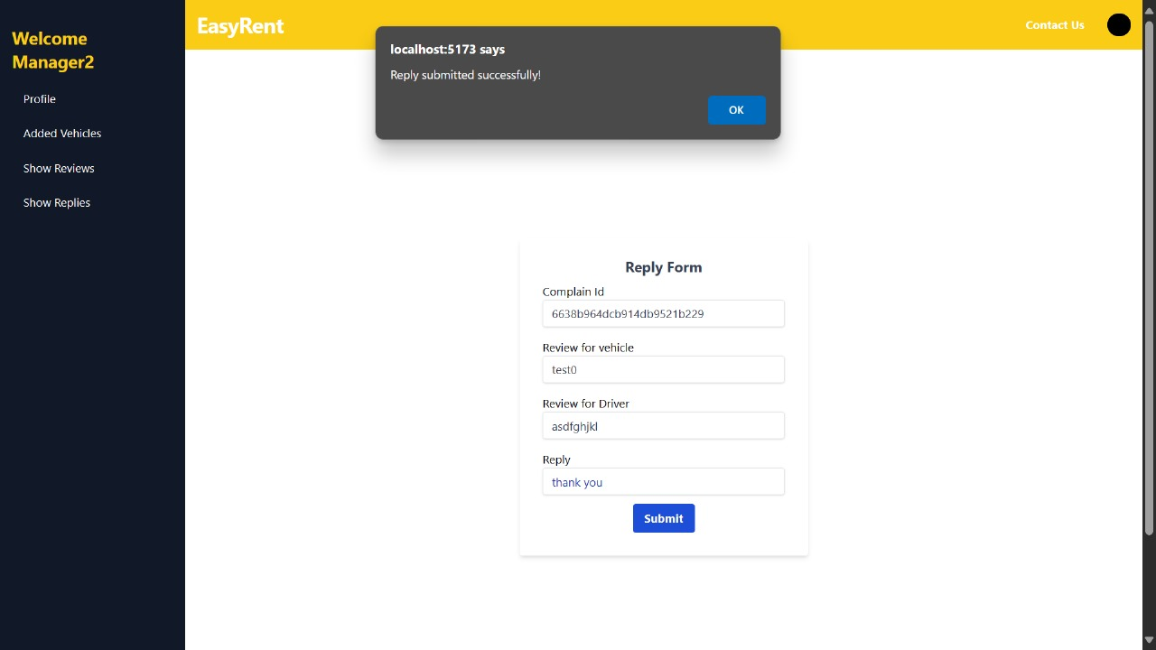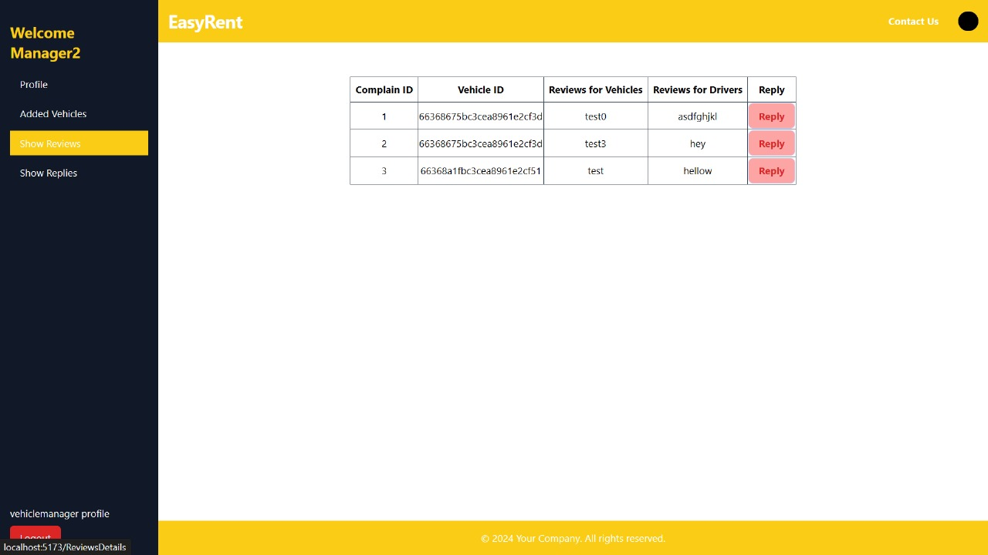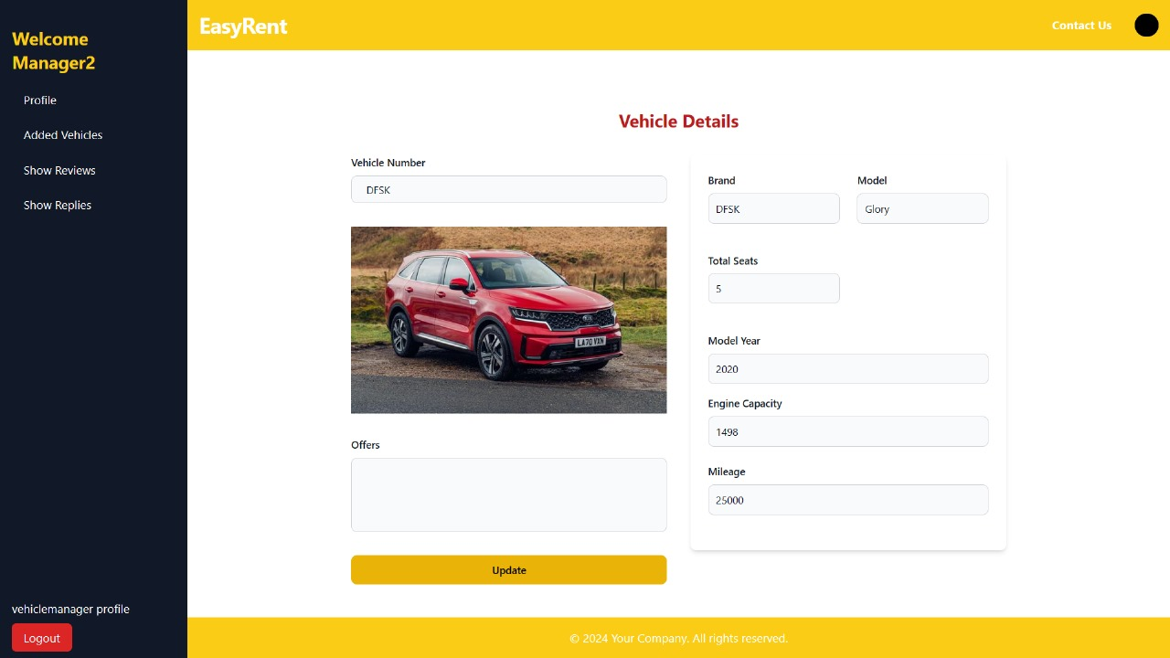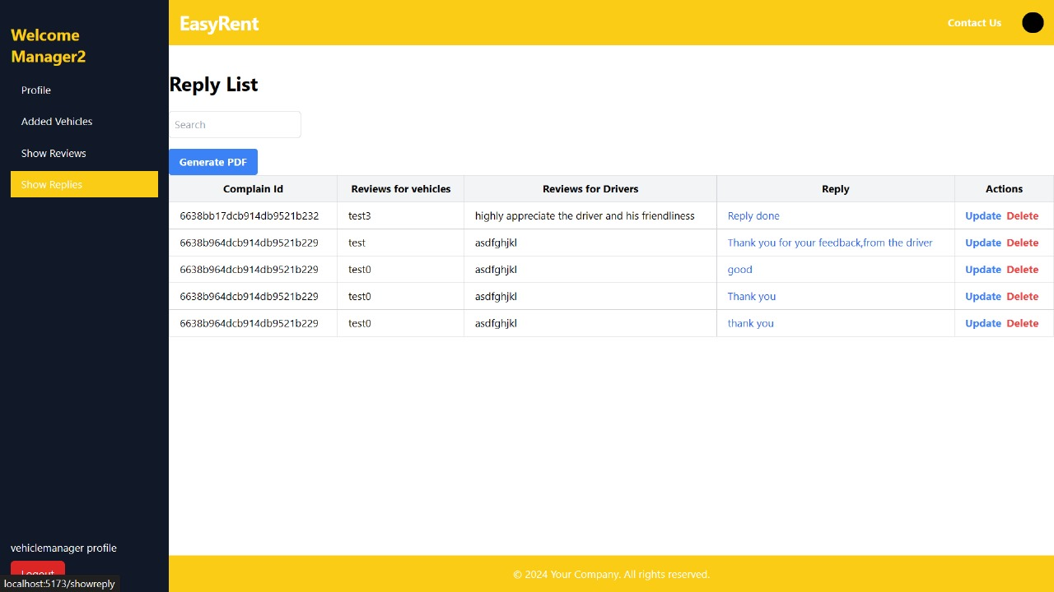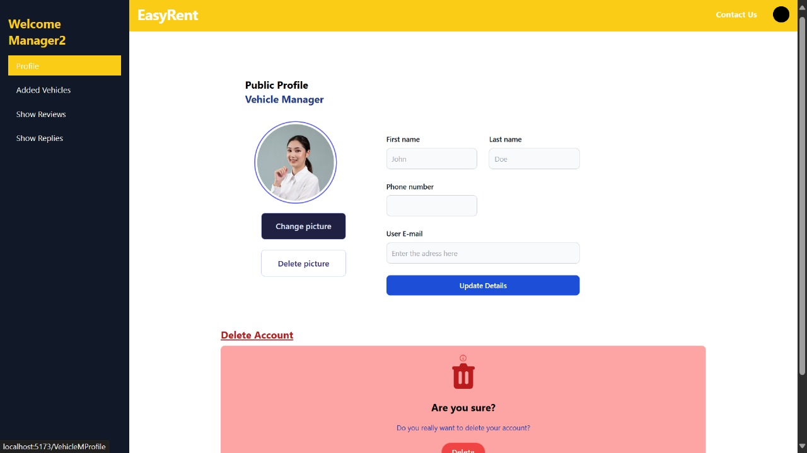

**HR Management System**

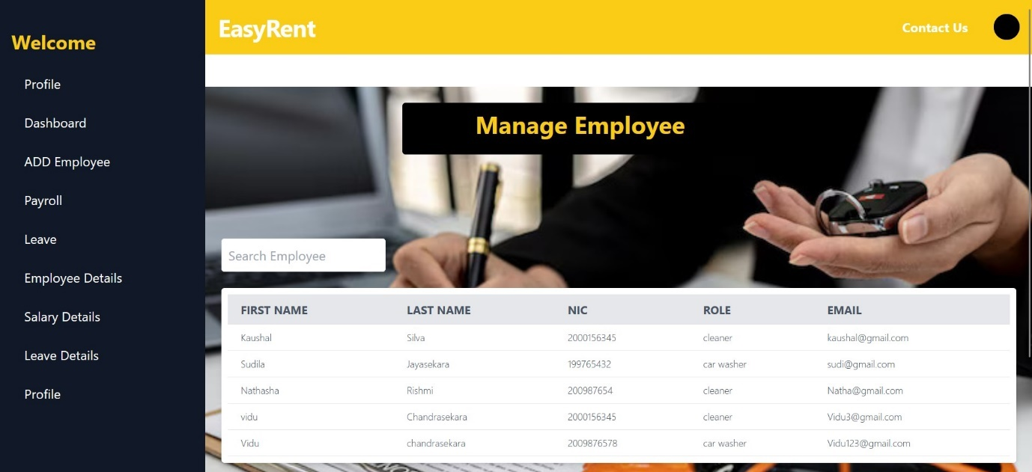

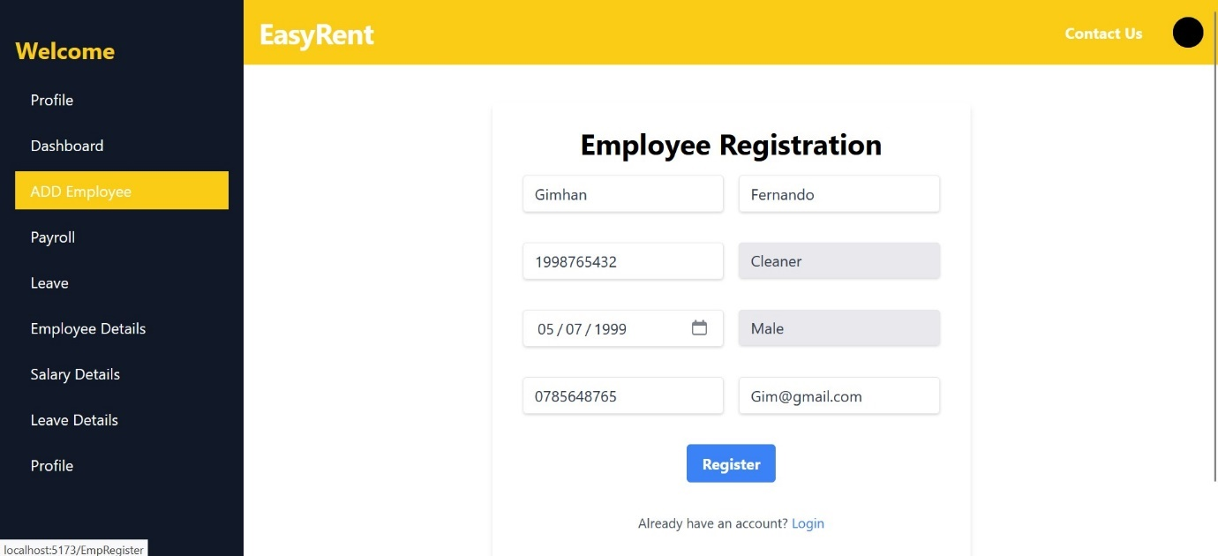

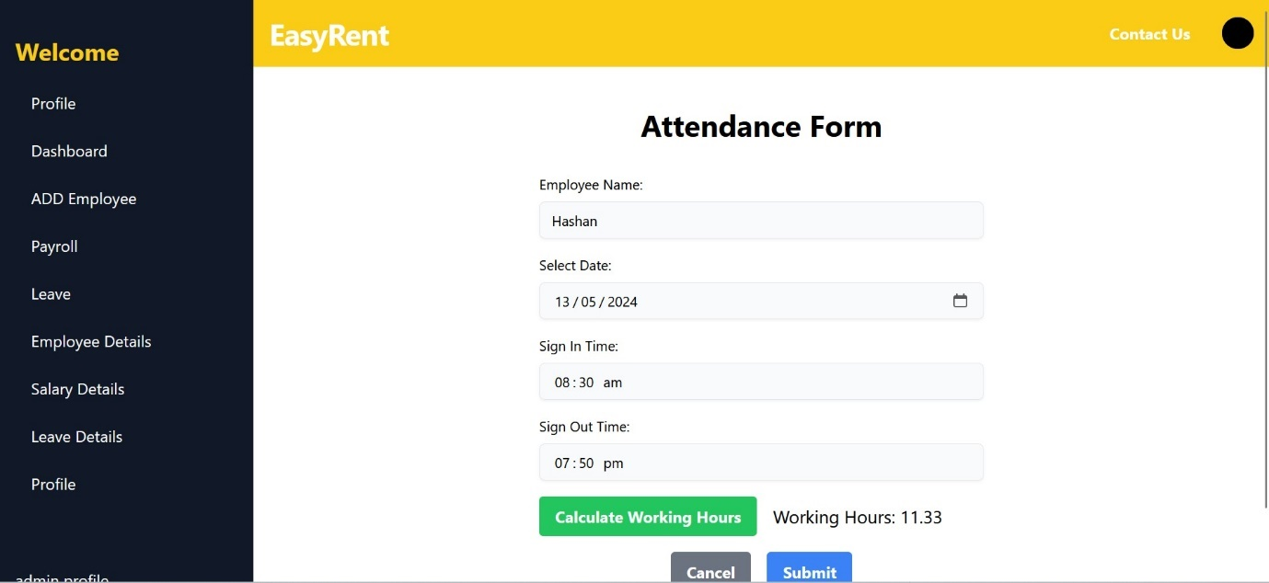

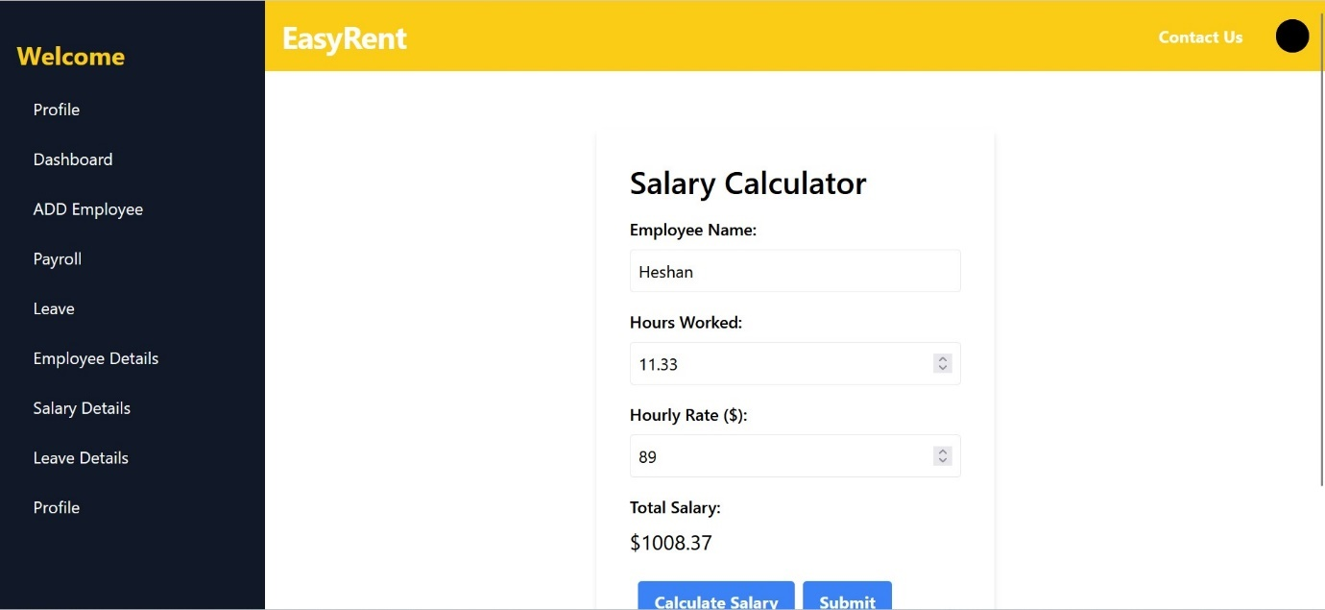

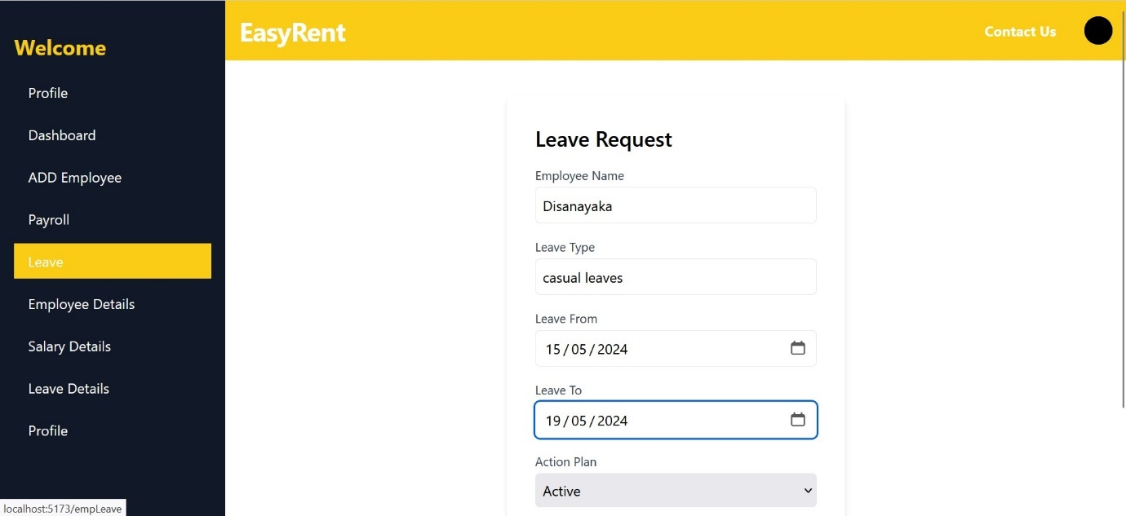

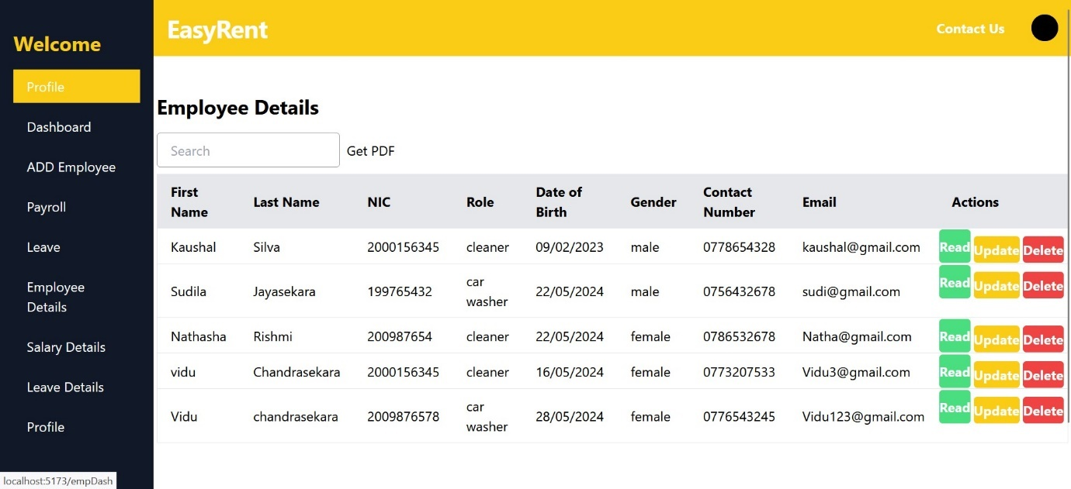

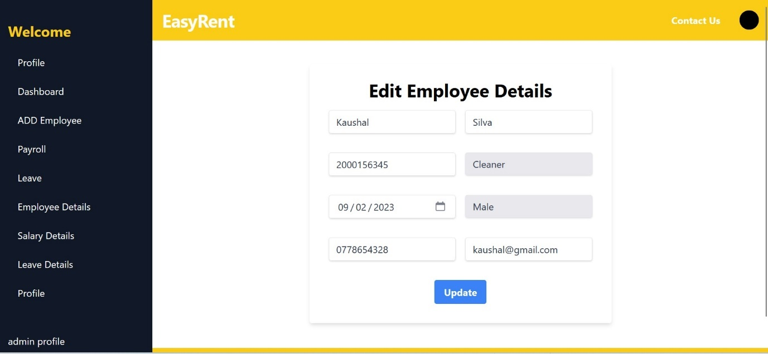

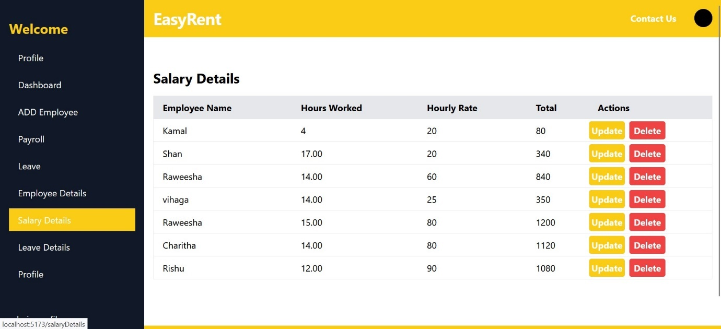

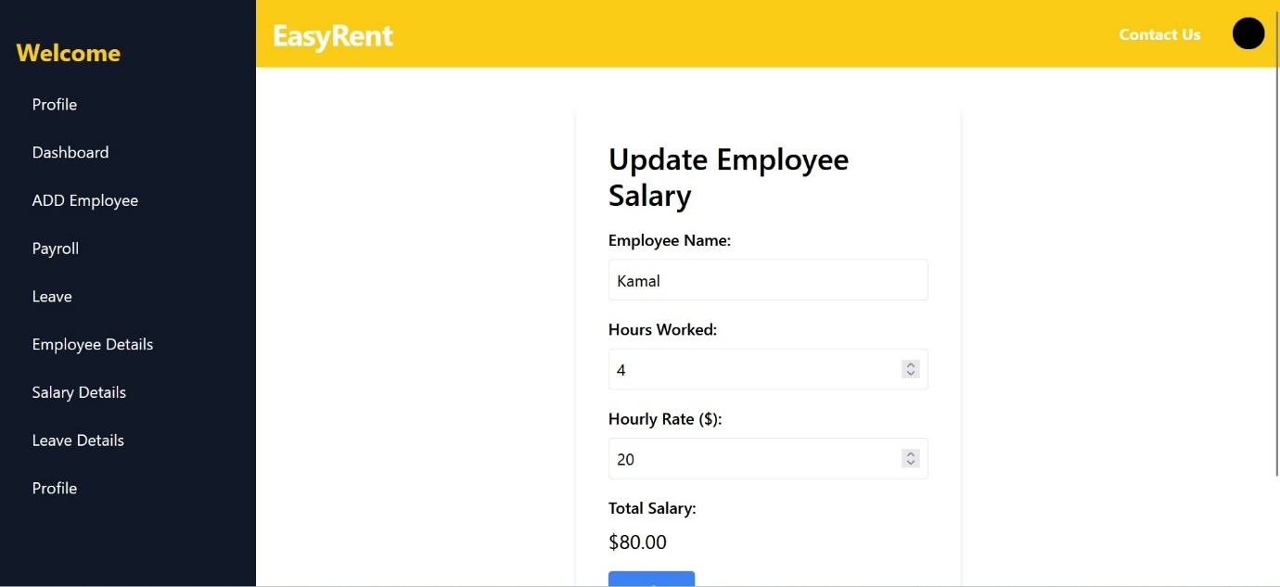

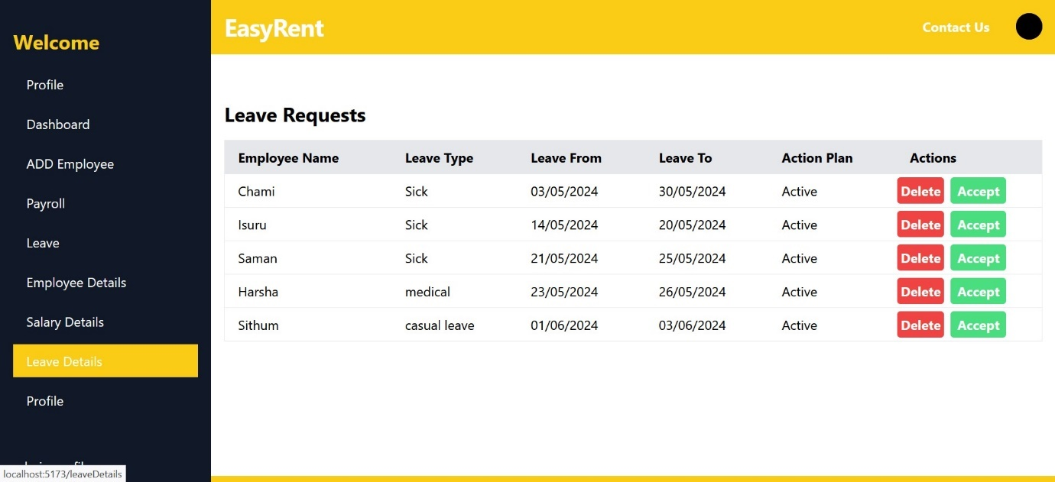

**Reviews and Ratings Management System**

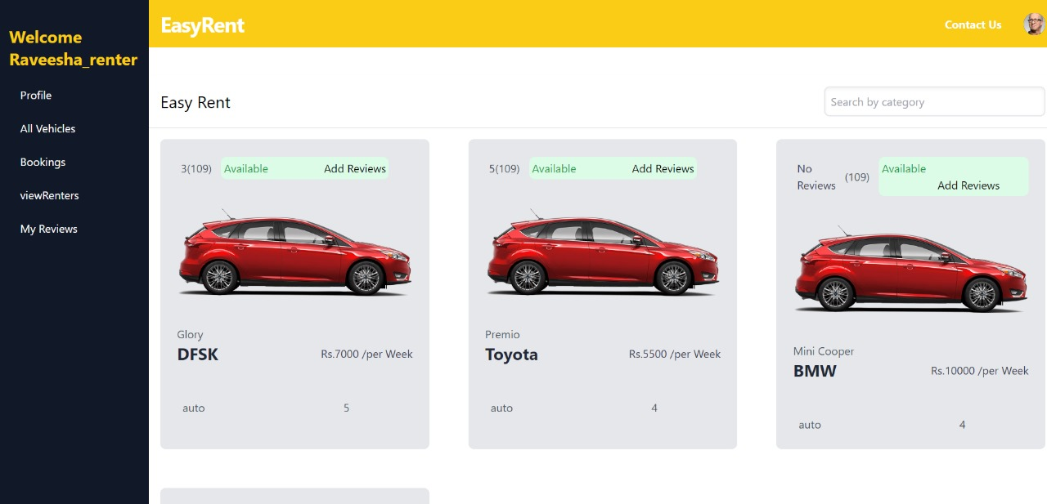

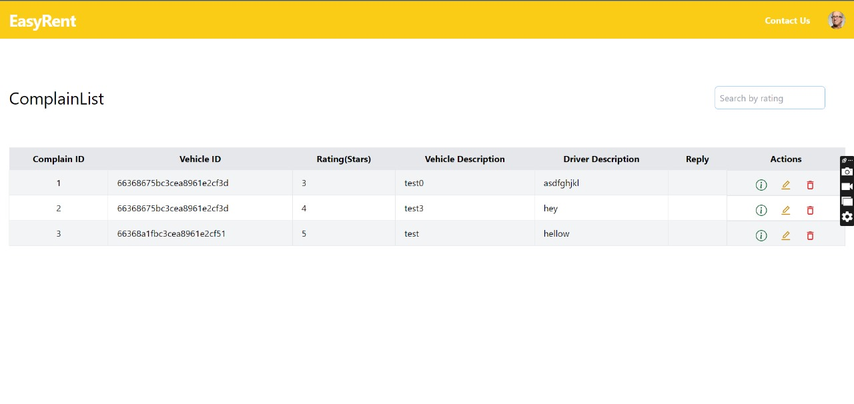

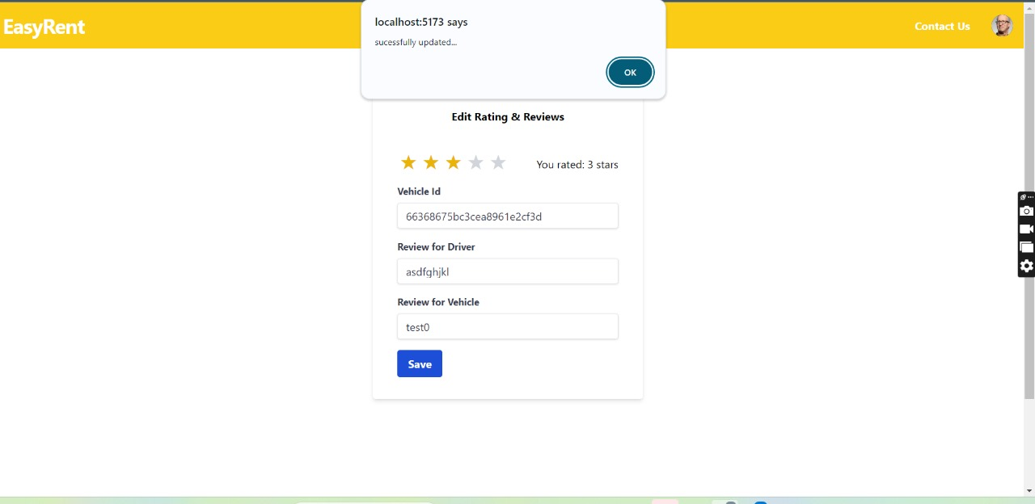

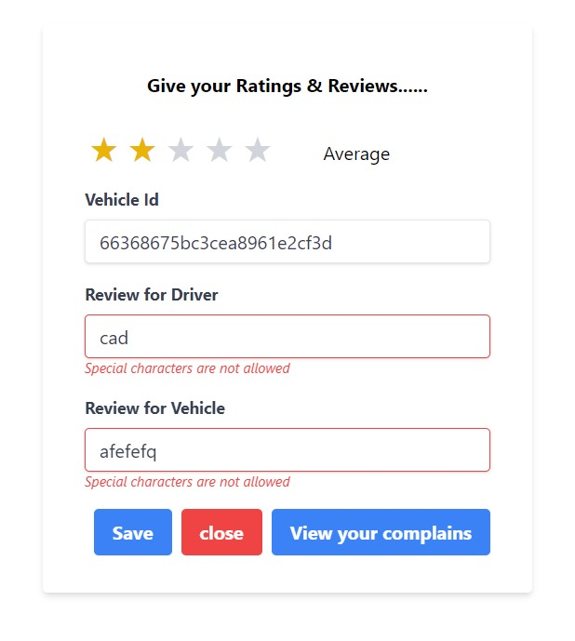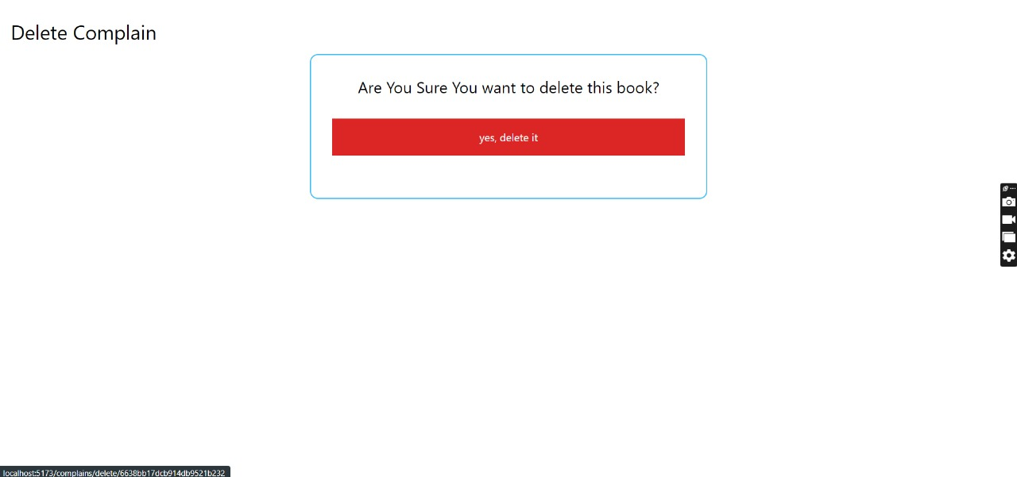

**Maintenance Management System**

## 

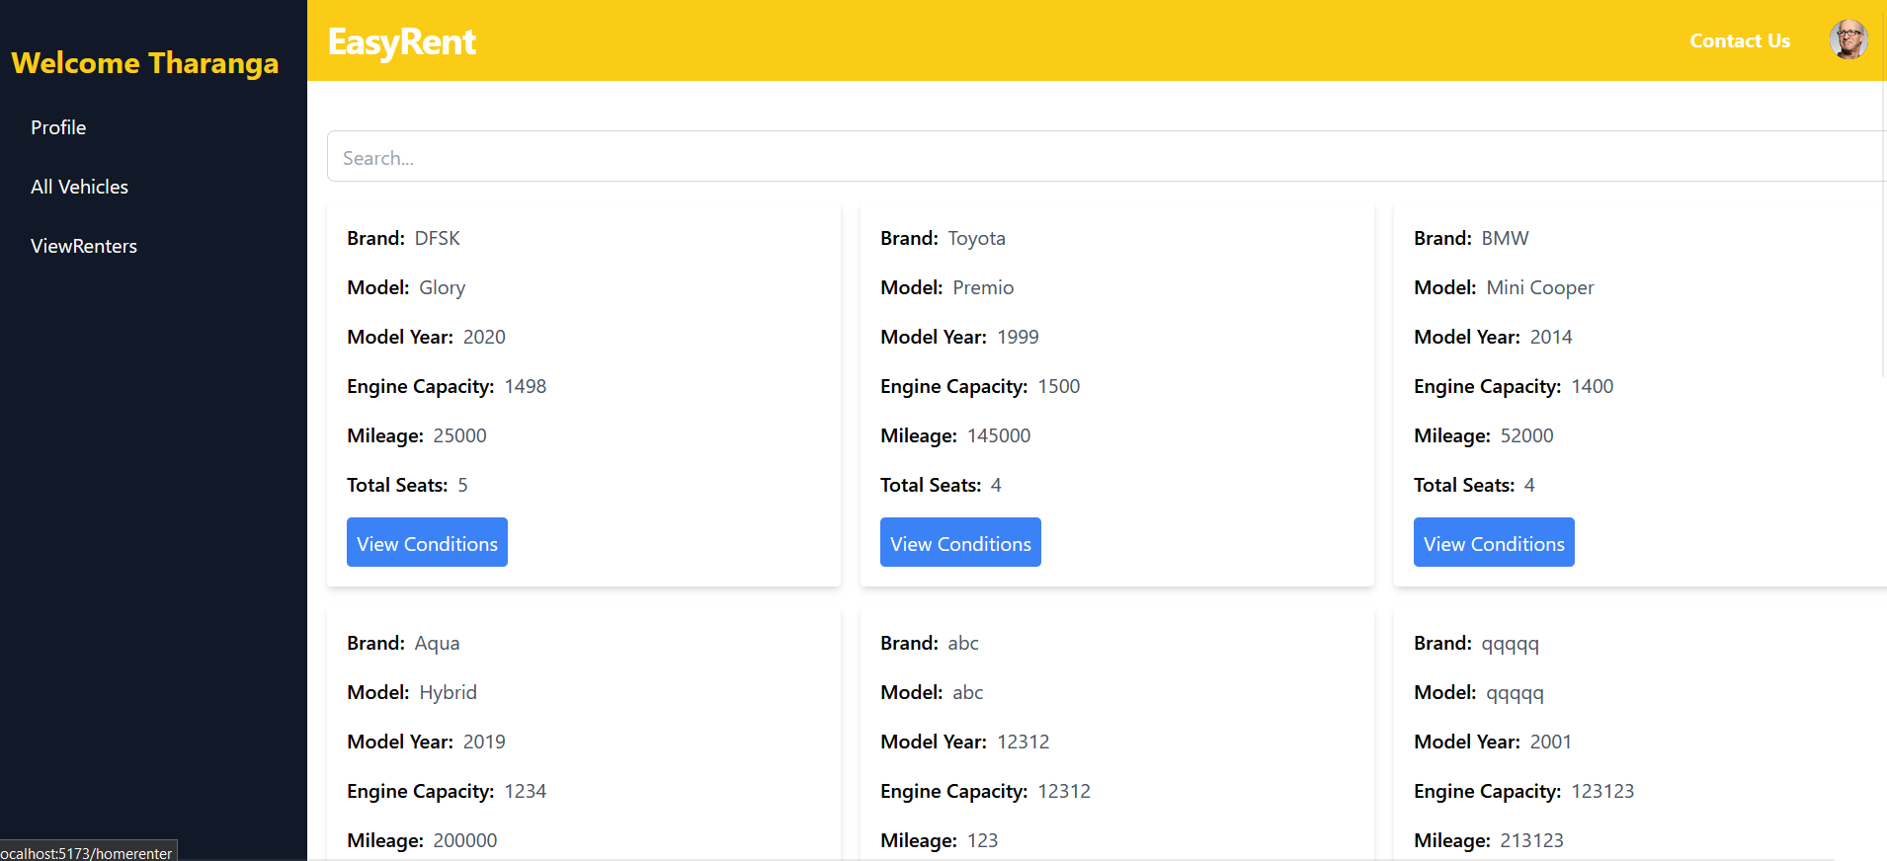

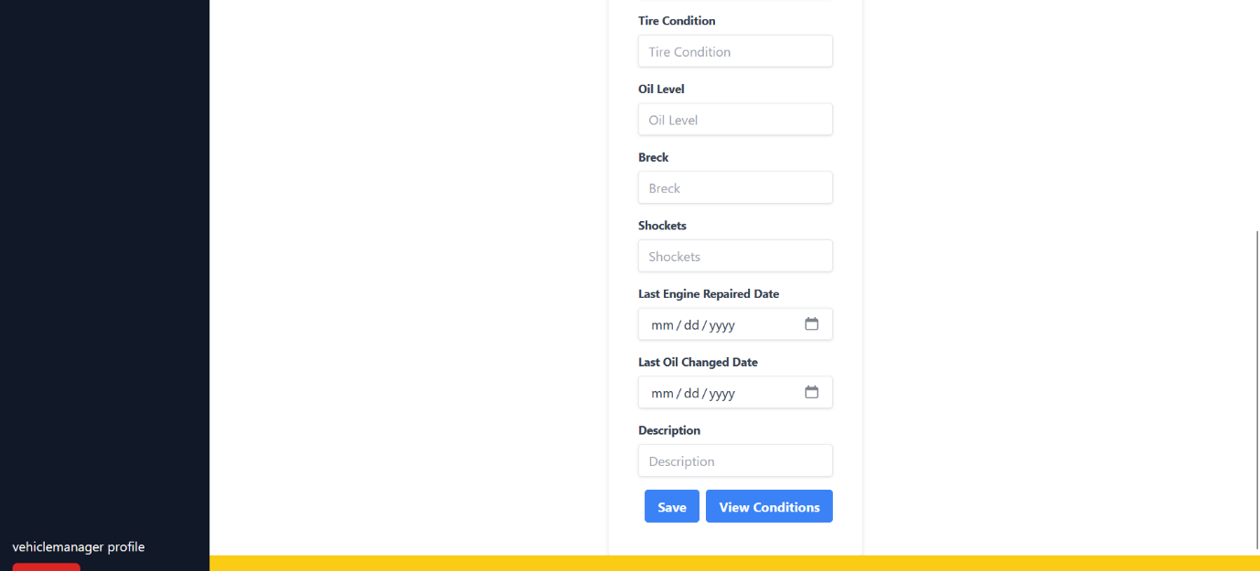

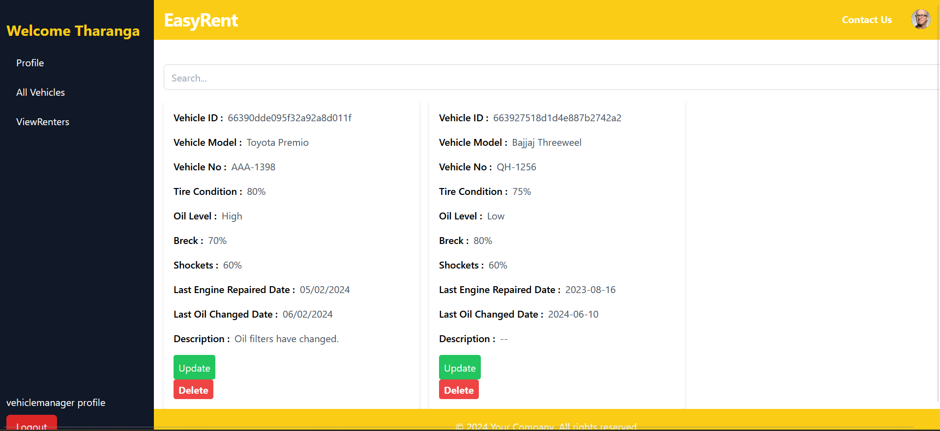

## 2.3 Implementation

The EasyRent application was built using the MERN stack on the VS Code platform. The team chose VS Code because of its user-friendly interface and advanced capabilities like syntax highlighting, bracket-matching, and auto-indentation.

MERN, an open-source and readily available framework, was chosen as the technology stack. The majority of the team members had previous experience with MERN, and its lower learning curve made it the ideal choice for the project.

The blend of backend technologies Node.js and Express.js with the frontend JavaScript framework React.js enables a smooth flow of JSON data from the frontend to the backend. This makes the system quick to develop and relatively easy to troubleshoot.

MongoDB, a NoSQL database that stores a collection of documents, was used in conjunction with Node.js. This combination simplifies the process of storing, manipulating, and representing JSON data.

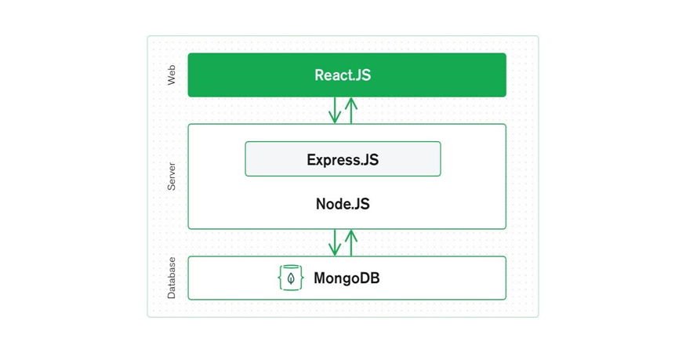



### 2.3.1 Tools and Technology

In our online vehicle rental management system project, we adopted a comprehensive set of tools and technologies to ensure effective design, collaboration, and project management.

### 2.3.1.1 Project Management and Documentation:

* **Microsoft Project:** Used for project management tasks, scheduling, and resource allocation.
* **Microsoft PowerPoint and Word:** Utilized for crafting the project proposal presentation, creating the scrum presentation, and finalizing the work proposal document. Microsoft Office suite proved instrumental in facilitating collaborative efforts.

### 2.3.1.2 Modeling and Drawing Tools:

* **Mock flow, Draw.io:** Employed for creating models and drawings. Mock flow for interface design, StarUML for UML diagrams, and Draw.io for collaborative drawing with shape libraries.

### 2.3.1.3 Design and User Interface:

* **Figma:** Employed Figma design software to ensure the design is clear and efficient. Figma is a powerful vector application tailored for productive and creative interface building for websites or apps.

### 2.3.1.4 Programming Languages and Development Environments:

* **JavaScript and Node.js:** Leveraged as the primary programming language and runtime environment for executing JavaScript code outside of a web browser.
* **Microsoft Visual Studio Code and Eclipse:** Chosen as the main integrated development environments (IDEs) for coding, with Sublime Text as the backup editor.

### 2.3.1.5 Application Development:

* **Express (Back-end Framework) and React (Front-end Framework):**
* **Express:** Utilized as the back-end framework, simplifying the development of multiplatform and online applications while incorporating necessary functionalities.
* **React:** Acted as the front-end framework, enabling the creation of intricate user interfaces for building single-page web apps.

### 2.3.1.6 Full-Stack Development:

* **MERN Stack (MongoDB, Express, React, Node.js:** Adopted for full-stack development. MongoDB served as the data storage, Express as the back-end framework, React as the front-end framework, and Node.js as the runtime environment. This combination enables the development of high-performance web applications.

This arsenal of tools and technologies, ranging from project management to development frameworks, ensures the project's success and efficient collaboration among team members. The chosen stack aligns with modern web development practices, providing a robust foundation for building and managing an online vehicle rental management system.

## 2.4 Testing

**Test Function:** Search Booking history

**Test Case Designed By:** IT22580344

**Test Priority:** High

**Pre-condition:** Renter must be logged into the system.

**Test Steps:**

* Vehicle Renter navigates to the "Booking" section.
* Enters search criteria such as vehicle type, location, availability dates, etc.

|  |  |  |  |  |  |
| --- | --- | --- | --- | --- | --- |
| Test ID | Test Inputs | Expected Output | Actual Output | Result | Description |
|  | Vehicle brand, Vehicle model, location, dates | The system should only display the relevant bookings that matching to search criteria | System display only relevant bookings the matching to search criteria | pass | The renter successfully searches for bookings |

**Test Function:** Generate Payment Report

**Test Case Designed By:** IT22580344

**Test Priority:** High

**Pre-condition:** Owner must be logged into the system.

**Test Steps:**

* Vehicle Owner navigates to the "Earning" section.
* Select a week, month or year for generate reports

|  |  |  |  |  |  |
| --- | --- | --- | --- | --- | --- |
| Test ID | Test Inputs | Expected Output | Actual Output | Result | Description |
|  | Select week, month or year for generate report | System should generate a report for all earning for entered period of time | System display generated report for owner earnings for selected time period | pass | The owner successfully generated report for earning |

**Test Function:** Adding vehicles details to the system

**Test Case Designed By:** IT22101242

**Test Priority:** High

**Pre-condition:** User has necessary permissions to add vehicle details

**Test Steps:**

* Enter valid vehicle details into the respective fields
* Check for a confirmation message indicating successful addition of vehicle details

|  |  |  |  |  |  |
| --- | --- | --- | --- | --- | --- |
| Test ID | Test Inputs | Expected Output | Actual Output | Result | Description |
|  | Vehicle details: brand, model, model year, engine capacity, total seats, vehicle id, start date, transmission, price, mileage | The owner adds the vehicle details and confirms successful addition. | Vehicle details are added, and the system displays a success message. | pass | Verify that the owner can successfully add vehicle details |

**Test Function:** Adding driver details to the system

**Test Case Designed By:** IT22101242

**Test Priority:** High

**Pre-condition**: The vehicle owner has necessary permissions to add driver details

**Test Steps:**

* Enter valid driver details in the form
* Check if the added driver details are visible in the system's database

|  |  |  |  |  |  |
| --- | --- | --- | --- | --- | --- |
| Test ID | Test Inputs | Expected Output | Actual Output | Result | Description |
|  | Form including driver’s name, email, contact no, NIC and other details | Driver details are successfully added to the system | Driver details added successfully | pass | Verify that the system can add driver details with valid inputs |

**Test Function:** Update Renter Profile

**Test Case Designed By:** IT22137128

**Test Priority:** Medium

**Pre-condition:** Renter must be logged into the system.

**Test Steps:**

* Renter navigates to the "Profile" section.
* Updates personal information such as name, contact details, or address.
* Saves the changes

|  |  |  |  |  |  |
| --- | --- | --- | --- | --- | --- |
| Test ID | Test Inputs | Expected Output | Actual Output | Result | Description |
| UP-01 | Updated name, contact details, address | System should save the updated profile information | System successfully saves the updated profile information. | pass | The renter successfully updates their profile information |

**Test Function:** Add Vehicle to Favorites

**Test Case Designed By:** IT22137128

**Test Priority:** High

**Pre-condition:** Renter must be logged into the system

**Test Steps:**

* Renter navigates to the "Vehicle Listings" section
* Finds a vehicle of interest.
* Selects the option to add the vehicle to favorites

|  |  |  |  |  |  |
| --- | --- | --- | --- | --- | --- |
| Test ID | Test Inputs | Expected Output | Actual Output | Result | Description |
| AVF-01 | Vehicle selected for addition to favorites | System should add the vehicle to the renter's favorites list | System successfully adds the vehicle to the renter's favorites list | pass | The renter successfully adds a vehicle to their favorites list for future reference. |

**Test Function:** Response for driver assigning for a hire. **Test Case Designed By:** IT22124876 **Test Priority:** High **Pre-condition:** Owner should assign a driver for the hire. **Test Steps:**

• Driver navigates to the “View bookings”. • Driver checks for the dates and the locations where the drivers have been assigned. • Response whether he can participate in the hire or not.

|  |  |  |  |  |  |
| --- | --- | --- | --- | --- | --- |
| Test ID | Test Inputs | Expected Output | Actual Output | Result | Description |
|  | Dates that the renters have done a booking. | Owners checked the dates and assign a suitable driver for the hire. | Assigning is accurately displays at the relevant driver’s profile. | pass | Renters can make a booking for a vehicle. So the vehicle owners can check the dates and assign a relevant driver to the booking. Drivers can watch the dates they have been assigned and response whether they can attend or not. |

**Test Function:** Adding Approved Vehicles to the system

**Test Case Designed By:** IT22230638

**Test Priority:** High

**Pre-condition:** Vehicle Manager must be logged into the system.

**Test Steps:**

* Vehicle Manager navigates to the “Approved Vehicles” section in the system.
* Check the approved vehicle forms.

|  |  |  |  |  |  |
| --- | --- | --- | --- | --- | --- |
| Test ID | Test Inputs | Expected Output | Actual Output | Result | Description |
|  | Approved vehicles’ forms | Approved vehicles successfully added to the system for rental. | Approved vehicles successfully added to the system for rental. | pass | The vehicle manager successfully add approved vehicle to the system after receiving approval form the maintenance manager. |

**Test Function:** Investigating Renter Complaints

**Test Case Designed By:** IT22230638

**Test Priority:** High

**Pre-condition:** Vehicle Manager must be logged into the system.

**Test Steps:**

* Vehicle Manager navigates to the “Reviews and Ratings” section in the system.
* Access the list of Reviews submitted by renters.
* Reviews and ratings for vehicles and the system are inspected thoroughly.

|  |  |  |  |  |  |
| --- | --- | --- | --- | --- | --- |
| Test ID | Test Inputs | Expected Output | Actual Output | Result | Description |
|  | Reviews and ratings provided by renters | Effectively investigate and respond appropriately to renter complaints by thoroughly analyzing reviews and ratings provided by renters. | Responding appropriately to address any identified issues or concerns. | pass | The vehicle manager effectively investigating renter complaints and responding appropriately to address any identified issues or concerns. |

**Test Function:** Add new employees to the system.

**Test Case Designed By:** IT22286246

**Test Priority:** High

**Pre-condition:** HR manager must be logged into the system.

**Test Steps:**

* Enter employee details by filling form.
* Click the register button.

|  |  |  |  |  |  |
| --- | --- | --- | --- | --- | --- |
| Test ID | Test Inputs | Expected Output | Actual Output | Result | Description |
|  | First name, Last name, NIC, Role, Date of birth, select gender, Contact number, Email | Create new employee in database.  Display registration successful message. | Add new employee to database and display “Employee data send successfully” message. | pass | Add a new employee to the system. |

**Test Function:** Leave request management.

**Test Case Designed By:** IT22286246

**Test Priority:** High

**Pre-condition:** Employee must be registered into system.

**Test Steps:**

* Employees navigate to “Leave Management” section in the system.
* Fill the leave request form.
* Click “Submit Request” button.

|  |  |  |  |  |  |
| --- | --- | --- | --- | --- | --- |
| Test ID | Test Inputs | Expected Output | Actual Output | Result | Description |
|  | Employee name, leave type, leave from, Leave to, Action plan | Apply leave request.    Display request successful message. | Add new request in database. | pass | Add a new request in the database and HR manager can review those requests. |

**Test Function:** Report Generation

**Test Case Designed By:** IT22271150

**Test Priority:** High

**Pre-condition:** Renter must be logged into the system.

**Test Steps:**

* Renter navigates to the "Reviews and rating page" section.
* Select the form to add reviews and ratings.

|  |  |  |  |  |  |
| --- | --- | --- | --- | --- | --- |
| Test ID | Test Inputs | Expected Output | Actual Output | Result | Description |
|  | Vehicle id.  Rating through stars.  Review for vehicle.  Review for Driver. | A detailed report should be generated, including information such as Reviews for driver, vehicle separately and rating through starts to trip. | The report is generated successfully and displays relevant data | pass | The renter  Can add reviews effectively and other renters can see all the reviews and rating in booking page. |

**Test Function:** Adding vehicle conditions to the system.

**Test Case Designed By:** IT22281128

**Test Priority:** High

**Pre-condition:** Maintenance manager must be registered into the system.

**Test Steps:**

* Maintenance manager navigates to “Vehicle Conditions” section in the system.
* Fill in the vehicle conditions form.
* Click “Save” button.

|  |  |  |  |  |  |
| --- | --- | --- | --- | --- | --- |
| Test ID | Test Inputs | Expected Output | Actual Output | Result | Description |
|  | Oil level, Tire condition, Breck, Shockets, Last engine repaired date, Last oil changed date | Update vehicle conditions in database.    Display request successful message. | Add new repair details to database and display “Vehicle conditions details update successfully” message. | pass | Add a new repair detail of vehicles to the system. |

# Conclusion

Easy Rent is a comprehensive vehicle renting and hiring management system designed to meet the diverse needs of vehicle rental businesses. By integrating modern technology and user-friendly interfaces, Easy Rent streamlines the entire rental process, from vehicle inventory management to customer reservations, payments, and reporting.

Our system provides significant benefits for both administrators and customers. Administrators can efficiently manage their vehicle fleets, track maintenance schedules, and monitor rental activities through a robust and intuitive dashboard. This enhances operational efficiency, reduces administrative overhead, and ensures optimal utilization of the vehicle inventory.

Customers benefit from a seamless and convenient rental experience. The user-friendly customer portal allows for easy browsing of available vehicles, straightforward booking processes, and secure online payments. Real-time availability tracking and clear reservation statuses improve transparency and customer satisfaction.

Easy Rent's scalability and flexibility make it suitable for a wide range of vehicle rental businesses, from small local companies to large enterprises with diverse fleets. The system's integration capabilities with third-party services and payment gateways further enhance its functionality and extend its value.

Moreover, the detailed analytics and reporting features of Easy Rent provide valuable insights into business performance, helping owners make informed decisions and drive growth. The focus on security and data protection ensures that both customer and business data remain safe and confidential.

Overall, Easy Rent represents a significant advancement in the vehicle rental industry, offering a powerful, efficient, and user-centric solution. By automating key processes and enhancing the user experience, Easy Rent empowers vehicle rental businesses to achieve greater efficiency, customer satisfaction, and long-term success.